State of New Jersey
Department of Human Services

SUBJECT: Standardized Board Resolution Form

EFFECTIVE: This policy shall become effective August 1, 2009.

PROMULGATED: July 20, 2009

SUPERCEDES: Standardized Board Resolution Form, promulgated November 21, 2007

PURPOSE: The purpose of this policy circular is to standardize the content of the Provider Agency Board Resolutions across all Department of Human Services (DHS) Departmental Components to assure that all of the required obligations are identified and committed to by the Provider Agency Board.

- SCOPE

This policy circular applies to all DHS Third Party incorporated contracted Provider Agencies, Universities/Colleges and for-profit organizations.

II. POLICY

Periodically Boards of Directors in conducting the business of their organizations attest to their actions or decisions by way of written resolutions. The DHS requires Contract Providers to complete and file the attached standard board resolution when executing a DHS Third Party Social Service Contract.

- Requirements for completion, updating and submission

The Attachment I, Page 1 is to be completed by the Agency and the same for Attachment II.

When any changes occur which would affect the contents of the form, the Board is to convene and complete a new Board Resolution and submit it to the Departmental Component within 10 business days of the change unless otherwise specified in the DHS policy.

The completed form is to be returned to the Departmental Component with all other required contract documents as part of the contract package. (See Policy Circular P1.01, Documents and Conditions Required for Processing, Executing and Documenting a DHS Third Party Contract.)

Issued by:

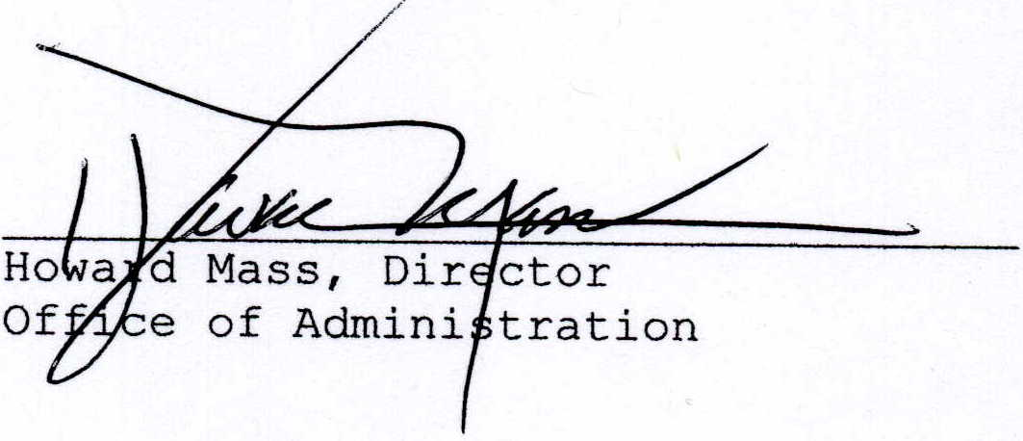

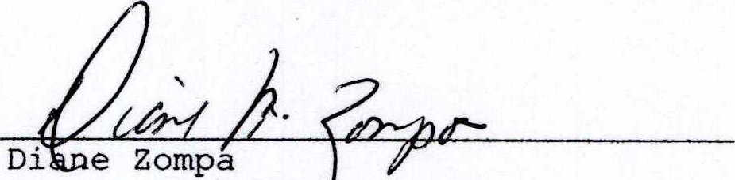
Chief of Staff
Department of Human Services

STANDARDIZED BOARD RESOLUTION

The Board endorses the following commitments as defined in this document:

- Health Insurance Portability and Accountability Act (HIPAA)*

Specific to HIPAA (Health Insurance Portability and Accountability Act), the above noted Provider Agency is either (check A or B):

___ A) a covered entity (as defined in 45 CFR 160.103)

___ B) a non-covered entity and has executed a DHS Business Associate Agreement (BAA) last dated ________.

___ C) a non-covered entity that will not be receiving or sharing
personal health information.

Once executed, the BAA will be included in the Departmental Component’s official contract file. The BAA will be considered applicable indefinitely unless there is a change in the Provider Agency’s status, information or the content of the BAA, in which case it is the responsibility of the contracted Provider Agency to revise the BAA.

The Board agrees that if there is any change in their BAA Status the Departmental Component will be immediately notified and the appropriate information provided within 10 business days.

* This section is not applicable for DCF Office of Education Contracts.

- Legal Advice

The Board acknowledges that the Department of Human Services does not and will not provide legal advice regarding the contract or about any facet of the relationship between the Department of Human Services and the Provider Agency. The Board further acknowledges that any and all legal advice must be sought from the Provider Agency's own attorneys and not from the Department of Human Services.

Page 1 of 1

DEPARTMENT OF HUMAN SERVICES (DHS)

Standardized Board Resolution Form

Supporting Information for Contract # _______________ for Contract

Period _________________________ to ______________________________.

Agency: ___________________________________________________________

Certification:

We certify that the information contained in, or included with, this contract document is accurate and complete.

__________________________________ __________________________
Chairperson, Board of Directors Date

__________________________________ ___________________________
Executive Director Date

Authorized Signatories for Contract documents, checks and invoices are: (List full name and title)(add additional pages, if needed)

__________________________________ _________________________________
Name Title

__________________________________ _________________________________
Name Title

__________________________________ _________________________________
Name Title

Page 1 of 1

