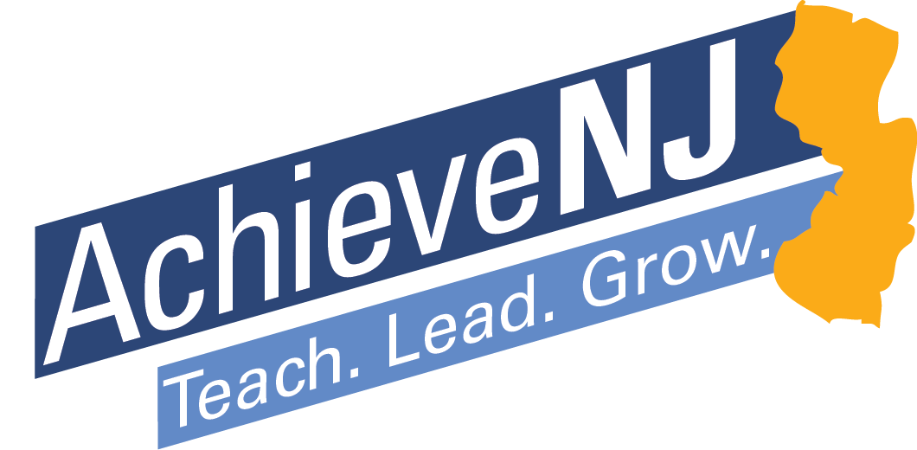

Student Growth Objectives
Developing and Using Practical Measures of Student Learning

State of New Jersey
Department of Education

Revised for 2015-16

Table of Contents

Part 1: Introduction 3
About This Guidebook 3
Requirements and Best Practices 3

Part 2: SGO 2.1: “On the Road to Ownership” 5

Part 3: The SGO Process 7
SGO Quick Start and Resource Guide: 7
Step 1: Choose or Develop Quality Assessments 9
Step 2: Determine Students’ Starting Points 15
Step 3: Set Ambitious and Achievable Student Growth Objectives 18
Step 4: Track Progress and Refine Instruction 23
Step 5: Review Results and Score 31

Part 4: Growth Objectives for Educational Service Professionals and Guidance for Administrators 34
Growth Objectives for Educational Service Professionals 34
SGO Implementation Advice for School and District Leaders 35

Appendix: Forms for Setting, Assessing, and Scoring Student Growth Objectives 37

Part 1: Introduction

About This Guidebook

This guidebook is intended to help teachers develop Student Growth Objectives (SGOs) with the support of their administrators and has been updated with guidance, resources, and tools for the 2016-17 school year. This information supports high quality SGOs that not only meet the basic requirements but become accurate measures of teaching practice and tools for increasing student learning. Please visit the SGO section of the AchieveNJ website for updates to this resource, SGO Frequently Asked Questions and exemplars, and to access a variety of optional forms.

Acknowledgements
The Department of Education is grateful for the hard work and input from educators throughout the state of New Jersey who gathered in various forms and locations in New Jersey and Washington, DC in putting together this guidance. This includes educators from the state AchieveNJ Advisory Committee, several State Teachers of the Year, numerous County Teachers of the Year, accomplished administrators and representatives from our state’s educational associations, school districts as well as content area specialists at the Department.

Requirements and Best Practices

Districts have a good deal of flexibility to develop SGOs that best suit their local needs. To help support this work, over the past three years the Department has continued to learn about and share best practices that add value to the SGO process. We encourage districts to use their District Evaluation Advisory Committee (DEAC), School Improvement Panels (ScIPs), and other leadership teams to ensure SGOs are working well for teachers and students.

Summarized in the boxes below are the requirements and broad contours of SGOs as well as those things that may be included to increase their quality and value, as informed by direct educator feedback from the first years of implementation.

Throughout the guidebook, requirements are noted in a red boxes. All other information is optional guidance.

REQUIREMENTS  Mandatory to Comply with Law |  | BEST PRACTICES  Optional to Increase Quality
Fulfill the legal requirement stated in the TEACHNJ Act that multiple measures of student growth and/or achievement be a component of every teacher’s evaluation.  - Teachers outside of 4th-8th-grade Language Arts and 4th-7th-grade Math must set 2 SGOs.  - Teachers of 4th-8th-grade Language Arts and 4th-7th-grade Math who will receive a median Student Growth Percentile score may set 1 or 2 SGOs but must have at least 2 measures of student achievement in order receive a summative rating.  Ensure SGOs are long-term academic goals that teachers set for students that are:  - Specific and measurable  - Aligned to state academic standards  - Based on student growth and/or achievement  - Set using available student learning data  - Developed by a teacher in consultation with his or her supervisor  - Approved and scored by a teacher’s supervisor  Include SGO scores as a percentage of every teacher’s evaluation score. |  | Use collaborative processes throughout SGO development, implementation, and scoring.  Design SGOs to include:  - A significant portion of high priority standards  - All or a significant proportion of students  - The majority of the school year  Only use assessments of the highest quality that produce accurate and consistent measures of student learning.  Use multiple measures of student learning to determine starting points.  Differentiate learning targets for groups of students (or individual students, when practical) based on starting points.  Make learning targets achievable but ambitious.  Integrate SGOs into the typical cycle of teaching and learning.  Innovate within the broad requirements of SGOs to develop SGOs that are more accurate measures of teaching effectiveness and authentic measures of student learning.

Part 2: SGO 2.1: “On the Road to Ownership”
The Department is committed to supporting the success of every school district and educator in their pursuit of strong local evaluation and support systems. This is particularly important in the area of developing good SGOs, a process that is still relatively new to all educators, even though many have long used certain aspects of this goal-setting process. The following graphic represents the evolution of SGOs since the first year of AchieveNJ implementation (2013-14).

The Department’s support regarding SGO development has been based on feedback we have received from educators from across the state. Feedback from the last two years highlighted the need for resources to help you design or choose high quality assessments. In addition, we have been continually asked to offer strategies to help make SGOs move past a form of compliance to one of quality in which educators felt it truly reflected and was integrated into their practice. The following points summarize key lessons learned through early implementation of SGOs.

- Assessments must be accurate and useful measures of student learning.
Increasing the quality of assessments given is critical in producing high quality SGOs. Building on this work, we are providing a series of Assessment Design modules, developed in collaboration with the U.S. Department of Education, to assist educators in your continued efforts to develop and choose high quality assessments. In addition, we are providing resources to help teachers use assessments throughout the teaching/learning cycle to monitor student performance and adjust instruction to help students reach their learning targets. See Step One and Step Four of this guidebook for more details.

- Student learning can be improved by using SGOs as a tool to enhance and inform teaching.
As educators become more familiar with the potential of SGOs to help improve student achievement, these measures become a valuable tool in raising student achievement. In order to integrate SGOs into the day-to-day world of classroom teaching, the process must produce data that is useful throughout the year, not just at the time of final scoring. Guidance for using SGOs in a cycle of data collection, analysis, planning, and implementing teaching strategies is described in detail in Step Four.

- Using a flexible and innovative approach to SGOs can increase their quality and value for teachers and students.
After two years of becoming familiar with the SGO process and taking steps to improve their quality, some educators and districts may be ready to innovate within the flexibility provided in SGO requirements. For example:
- Teachers may wish to explore a performance-based approach or other form of SGO assessment that relies on more than just one test at the end of the year.
- Districts may build in efficiencies in their testing schedules that allow SGO assessments to count for both SGOs and for students’ grades.
- School administrators might adjust scheduling to provide more time for teams of teachers to plan and learn together so that everyone can get the most out of the SGO process.
- Teams of educators may develop an innovative scoring plan aligned to a common assessment that provides a more accurate measure of the growth of their students.
Examples of possible innovations can be found throughout this guidebook; we strongly encourage districts to try different approaches to emphasize activities that benefit teachers and students the most.

- Collaboration with colleagues is a critical component of both the SGO process and helping students achieve the goals their teachers set for them.
When functioning at the highest level, SGOs are a process that collaborative teams of educators use to inform instruction and improve student achievement. As has been noted in the past, SGOs should be collaborative, teacher-driven, administrator-supported, and student-centered. This collaborative process should happen not only in the creation of SGOs and mid-year check in, but also during Step Four of the SGO process. The most critical time for success on an SGO occurs between the time starting points are determined and the assessment is given. See Step Four for more information on this.

Part 3: The SGO Process

SGO Quick Start and Resource Guide:

The following summarized steps of the SGO process are explained in full starting on page 9.

Before beginning:
- Review the broad guidance on developing quality SGOs bulleted below:
  - Design or choose assessments that yield accurate and consistent data.
  - Determine starting points using multiple data sources.
  - Differentiate learning targets for groups (or individual) students depending on their starting points.
  - Integrate SGOs into the typical cycle of teaching and learning.
  - Collaborate with colleagues and administrators to improve the value and quality of SGOs.
  - Innovate within the broad requirements to develop SGOs that are more accurate measures of teaching effectiveness and authentic measures of student learning.
- Review the AchieveNJ SGO Web Page for the most up-to-date materials and resources.

Step 1: Choose or develop a quality assessment aligned to New Jersey academic standards.
- Utilize collaborative team time to do as much of the following as possible:
  - Develop high-quality department-wide/grade-level assessments,
  - Agree to the types of information that will count for student starting points.
- Select and prioritize the standards you will be teaching during the SGO instructional period (including a significant proportion of the appropriate standards and students). Choose an assessment method appropriate to your content area and grade level that is:
  - Aligned to standards;
  - Aligned with the rigor of the standards, content, and instruction of the course;
  - Free of bias;
  - Precisely measuring of a student’s knowledge and skills; and
  - Administered and scored accurately and consistently.
- Use the Assessment Design modules to guide you through the process of developing an assessment.
- Review the SGO Quality Rating Rubric (PDF | Word).
Resources:
Assessment Design modules’ Blueprint
SGO 2.1 Presentation

Step 2: Determine students’ starting points.
- Determine how to employ useful data for determining the starting points of your students.
- Choose two, three, or more sources of information to get a rough sense of how prepared your students are to learn the information you will be teaching to the level you expect them to learn it.
- If using a diagnostic pre-assessment, make sure it will be:
  - Used in conjunction with other starting point information;
  - Evaluating improvement in a set of skills;
  - High-quality and vertically aligned; and
  - Normally used for instructional purposes.
- Group your students according to their starting points, or use individual targets, if practical.
Resources:
SGO 2.1 Presentation
Step 3: Set ambitious and achievable SGOs with the approval of the principal/supervisor.
- Develop SGOs in collaboration with your supervisor to enhance their value to you and your students.
  - Using knowledge of the students, standards, and SGO assessment, agree upon a vision for student mastery of the standards you have selected for your SGO.
- When setting goals, differentiate students based on their starting points.
- Set learning goals that are ambitious and achievable for all students.
  - When completing a scoring plan, make sure it reflects the realities of your classroom.
- Complete the SGO Form (PDF | Word), consulting with your supervisor to discuss your assessment(s), SGOs, and scoring plans.
Resources:
SGO 2.1 Presentation
Assessing and Adjusting SGOs (Word | PDF)
Evaluating SGO Quality Presentation (PPT | PDF)

Step 4: Track progress, refine instruction.
- Integrate SGOs into the typical cycle of teaching and learning.
  - Collaborative teams can help improve the process.
- Set a variety of long and short term assessments need to monitor progress.
  - Use long-cycle monitoring checkpoints to assess learning using unit assessments that cover all the standards taught during a specific timeframe within the SGO period.
  - Use short-cycle monitoring within longer cycles using a wider variety of assessment techniques.
- Meet with supervisor at the recommended mid-year check-in to discuss progress.
Resources:
Mid-course Check-in (PDF | Word)
Collaborative Team Toolkit Resources (Coming soon)
SGO 2.1 Presentation
Assessing and Adjusting SGOs (Word | PDF)
Evaluating SGO Quality Presentation (PPT | PDF)

Step 5: Review results and score in consultation with your supervisor.
- Collect information about student learning from the SGO assessment and calculate your SGO score according to the approved scoring plan.
- Consult with your supervisor to share the information and discuss your final score.
- Discuss lessons learned with your supervisor and steps for setting SGOs in the following year.
Resources:
Administering and Scoring SGO Assessments (Word | PDF)
SGO Scoring Checkpoints and Considerations (Word | PDF)
SGO Scoring Checklist (Word | PDF)
Optional Annual Conference Forms (mSGP teacher/non-mSGP teacher)

Getting a Head Start

Because you must develop your SGOs and have them approved by October 31, starting the SGO process as early as possible is beneficial. This will give you time to identify or create assessments on which you might set objectives or gather baseline information at the beginning of the year. Figure 1 depicts a suggested timeframe for various parts of the SGO process.

Figure 1: Timeframe for Steps of the SGO Process

Time Window | Component of SGO Process
April – September | Choose or develop assessments
September – October | Determine starting points and set learning goals
October 31 | Deadline for having SGO approved by supervisor
October – May | Track goals and refine instruction
January – February | Optional mid-year check in with supervisor
May – June | Review results, evaluator scores SGO

Step 1: Choose or Develop Quality Assessments

Choose/Develop Assessments
Determine Starting Points
Set Growth Objectives
Track Progress
Review and Score
1

2

3

4
5

The Value of Quality Assessments
Figure 2: SGO Quality and Assessment Quality
Teachers, principals, and others who are directly responsible for the educational growth of students in a school district have a professional responsibility to determine what and how much students are learning. Good assessment is integral to the art and science of teaching and allows educators to make informed decisions about the wide range of school-based factors that influence each child’s development. In your classroom, the quality of the assessments you use is inextricably linked to the quality and value of your SGOs. High-quality assessments allow you to accurately gauge the progress of your students to help you adjust instruction and also determine ultimately what your students have learned. See Figure 2.
SGO
Quality
Assessment
Quality
Poorly designed assessments do not accurately measure student knowledge and learning.

If SGOs do not yield accurate or meaningful results, they will fail to promote good instruction and
improve student learning.

If SGOs are based on low-quality assessments, then the SGO process cannot yield accurate or meaningful results.

depends upon

Beginning with the End in Mind
Effective teachers begin the year asking themselves:
- What should my students learn by when?
- What methods will I use to ensure they learn it?
- How will I know they have learned it?

These questions represent the standards, instruction, and assessment components of a teacher’s work and converge within the structure of an SGO. “Beginning with the end in mind” is a well-recognized approach for improving performance and is fundamental to “Understanding by Design” methods that many educators already use. The following sections provide suggestions for how to approach assessment design using this backwards planning approach and are summarized in the box below.

High-quality assessments must:
- Align with standards taught during the SGO instructional period;
- Align with the rigor of the standards, content, and instruction of the course;
- Be equally accessible to all students regardless of background knowledge, cultural knowledge, and personal characteristics; and
- Be administered and scored accurately and consistently.

The Purposes of Assessment
Assessments are the processes and tools that measure what students know and can do. Defined below are the four purposes of assessment, each of which can play a vital role in the SGO process.
- Diagnostic Assessment: Teachers use diagnostic assessments to determine their students’ knowledge and skills before a unit of instruction (for example, pre-tests, individual or group discussions with students, or sample work completed by students before the unit of instruction among others). For SGOs, diagnostic assessments may help determine student starting points but can only inform a piece of the learning trajectory of students. Teachers should also use other sources of data to more accurately determine student starting points.
- Formative Assessment: Formative assessments are used to monitor student learning and adjust ongoing instruction. For example, checks for understanding and quizzes usually serve a formative purpose.
- Summative Assessment: Summative assessments measure student mastery of standards at the end of a unit of instruction. For example, end-of-unit or term tests usually serve a summative purpose.
- Interim Assessment: Interim assessments fall somewhere between formative and summative. They measure students’ knowledge and skills on a specific set of academic goals, typically within a particular time frame.

The Assessment Design Toolkit
Over the past year, the Department collaborated with the United States Education Department to develop a series of modules on assessment design. Titled “The Assessment Design Toolkit,” this resource is intended to help all teachers recognize and develop high quality assessments. The Toolkit includes 13 “modules” divided into four parts:
(1) Key concepts;
(2) Five elements of assessment design;
(3) Writing and selecting assessments; and
(4) Reflecting on assessment design.

The modules address how to plan, write, and select well-designed assessments (and do not cover how to use assessments to measure student growth). The Assessment Design Toolkit includes videos and supplemental materials to help teachers write and select well-designed assessments. The complete array of resources can be found at http://csai-online.org/spotlight/assessment-design-toolkit.

Assessment Design and the Assessment Design Blueprint
An assessment blueprint is a tool that can be of great value for constructing assessments or evaluating the quality of those that have already been created. Just as architects and contractors use a blueprint to guide their work in designing and building a house, educators can use a blueprint for assessment design and development. The blueprint helps to make sure that your assessment is well-constructed and documents the nature of the assessment in a simple and clear format for review by colleagues and administrators.

The Assessment Design Blueprint accompanying the modules includes a table with directions and a blank template that you can use in designing your own assessments. An Assessment Blueprint example has also been provided to aid you in the process.

The six steps of assessment design captured in the Assessment Design Blueprint are as follows:
- Determine the primary purpose of the assessment.
- Identify the standard or standards you will assess.
- Identify the skill or skills addressed in each standard.
- Identify the level or levels of rigor of each skill.
- Identify possible types of assessment items.
- Write and/or select assessment items.

These steps highlight the aforementioned idea of “beginning with the end in mind.” This process of backward design is critical in developing high quality assessments. This includes determining which standard or standards you plan to measure, followed by designing an assessment to measure mastery of the selected standard or standards and planning your instruction.

Elements of Assessment Design
The following four numbered sections provide information about the elements of assessment design that you should be familiar with as you develop, modify, or choose an assessment for your SGO.

1. Assessments should be “aligned” with the standards taught during the SGO period.
- Why? By aligning your assessment to academic standards, you make sure that the assessment is measuring the degree to which your students learned those standards you were teaching during the SGO period. This increases the validity – or accuracy – of the conclusions you can draw about what your students have learned. Additionally, educators often face significant challenges in adequately teaching all of the grade-level standards to all of their students each year. A well-designed SGO and assessment foster a focus on those standards most critical for students’ future success as well as a means to assess these at a more meaningful level.

- How? A high-quality assessment contains a variety of items proportional in number and point value to the relative value of the standards taught. For example, a standard that students are expected to master in order to move on to the next level of instruction would be weighted more heavily in the assessment than a supporting standard. For example, in algebra, a critical standard that would have more weight in the assessment requires students to “interpret parts of an expression, such as terms, factors, and coefficients” (HSA.SSE.1.a). A supporting standard with proportionally less assessment weight requires students to “factor a quadratic expression to reveal the zeros of the function it defines” (HSA.SSE.3.a).

The suggested process of standards alignment can be broken down into three steps, the first two of which reflect the backwards planning approach discussed above:

- Identify Standards
  - Determine the instructional goals of the district, school, and content/grade department and which standards must be taught to meet these goals.
  - Identify the standards normally taught during the SGO instructional period.
- Prioritize Standards
  - Identify those standards that take more time to teach, lead to enduring understanding, are critical for college/career/life, and/or are most important for your students to learn based on their starting points.
- Align Assessment to Identified Standards in Proportion to Their Relative Importance

2. Assessments should be aligned with the “rigor” of the standards, content, and instruction of the course.
- Why? When you ask questions in an assessment that reflect the cognitive rigor -- or depth of knowledge -- of your course and instructional methods, you also ensure that the assessment accurately measures the level at which students have been expected to perform throughout the course. In addition, a wide range of cognitive demand in an assessment provides a more accurate picture of student learning across the performance spectrum.

- How? Here is a suggested approach to aligning the assessment to rigor of the course:
- View the Assessment Design module on rigor.
- Review the cognitive demands of the standards you will be teaching.
- Review the types of assessment items (formative and summative) you typically provide your students and check level of cognitive demand.
- Create an approximate profile of the range of rigor you expect in your class using the Depth of Knowledge Wheel, Bloom’s Taxonomy, or some other table of cognitive demand.
- Use the Depth of Knowledge/Rigor Chart and Checklist to develop a profile of your SGO assessment.

3. Assessments should be free of “bias” and should be “precise” – truly measurable of a student’s knowledge and skills – as well as equally accessible to all students regardless of background knowledge, cultural knowledge, and personal characteristics.
- Why? To be an effective measure of what you have taught students, assessments must be constructed in a way that decreases bias and increases the accessibility of the assessment for all students. An assessment must be carefully vetted to remove or modify questions that could unfairly advantage or disadvantage certain students based on their socio-economic status, sex, religious affiliation, race, personal characteristics, and/or extra-curricular background knowledge.
- How? Consider using the following steps to ensure assessment accessibility:
- View the Assessment Design modules on bias and precision
- Use the SGO 2.0 Presentation) (part 2) to practice analyzing assessment items that have low accessibility.
- Inspect all assessment items and the underlying structure of the assessment and modify as needed to ensure they are accessible to all students.

4. Assessments should be administered and “scored” accurately and consistently.
- Why? No matter how well constructed an assessment is, if it is administered or scored inconsistently, it will fail to provide a reliable measure of learning over time and across groups of students taking the assessment. Ensuring consistent high-quality administration and scoring makes the conclusions you can make about what your students have learned -- and how effective your teaching has been -- more reliable.

- How? Assessment experts recommend a variety of approaches for increasing the reliability of assessments including the following:
- View the Assessment Design modules on introduction to assessment design and scoring.
- Provide a physical and emotional environment that encourages students to do their best.
- Provide clear directions and scoring criteria to students before they start the assessment.
- Allow enough time to complete the assessment.
- Make the assessment long enough (longer assessments are generally more reliable).
- Ensure scoring is done by educators trained using clear criteria; use multiple scorers when possible.
- Keep the assessment secure before and after test.

More detailed suggestions for administering and scoring assessments can be found here.

Use Assessment Approaches that Make Sense

A variety of assessment options is available: Bearing in mind that assessments should always be an authentic and accurate measure of what your students know and can do, evaluate your options when deciding on the right way to develop SGO assessments. As well as typical pencil and paper tests, teachers may choose from a wide range of assessment options. Some of these are shown below in Figure 3.
Figure 3: Some Types of Assessments Appropriate for SGO Setting

Traditional Assessments | Portfolio Assessments | Performance Assessment
- National/State tests (e.g., Advanced Placement, DIBELS, EOC Biology)  - District, school, and departmental tests (e.g., final exams, modified as necessary) | - Teaching Strategies Gold® (pre-K, K)  - Writing and reflection samples (LAL)  - Laboratory research notebook (sciences)  - Portfolio of student work (visual and performing arts, etc.)  - Student project-based assessments (all subjects) | - Lab Practicum (sciences)  - Sight reading (music)  - Dramatic performance (drama)  - Skills demonstration (physical education)  - Persuasive speech (public speaking)

Note: The modules on constructed response items, selected response items, portfolios, and performance tasks can be found here.

Consider using more than one assessment method: Using multiple measurements of student performance has value not just when determining starting points but also when evaluating how much your students have learned. For example, a science teacher might set learning targets in an SGO for a written, content-based assessment plus a performance-based assessment. A writing teacher might assess her students’ progress over several assignments using a portfolio based approach.

Embed SGO assessments in the current testing schedule: Whenever possible, avoid making the SGO assessment an additional test students must take. Instead, plan to incorporate the assessment into the typical testing schedule. There are several approaches that might be used:
  - Make existing assessments do “double duty,” both for their prior purpose and for SGOs, e.g., end of unit tests in the model curriculum, or reading assessments typically used by elementary school teachers.
  - Use a portfolio-based approach and collect information on students over an extended period of time, e.g., a collection of different pieces of artwork.
  - Replace an existing test with the SGO assessment.

Quality check commercial assessments: All assessments, even those that are commercially available, should measure what they purport to measure. Often, commercial assessments will have a high level of rigor and reliability that provides value to educators. However, it is particularly important to check that the assessment is closely aligned to the standards that you are teaching.

Note: The results on some commercial or standardized assessments may not be available until after the school year ends. In this case, the district must weigh the benefits of the rigor and reliability of the tests with the inconvenience of not having data in time for a teacher’s summative rating before the end of the school year. If test scores are not available in time for annual conferences, a conference should be held during the next school year once the SGO ratings are available.

Use common assessments: Whenever practical, consider using the same assessment as your colleagues who teach the same subject and grade. Not only will this help provide consistency in instruction, it will increase the comparability of SGOs. If there is no common assessment for a subject and grade level, working to develop one can be a valuable way to use professional development time. Even if you teach a stand-alone course, such as Introduction to Finance, you may still be able to obtain your colleagues’ input on the structure of the test and quality of the questions.

Administrators Examine and Approve SGO Assessments
By October 31, SGOs must be developed by teachers and approved by their administrators. Because the goals set on each SGO depend on the SGO assessment, a critical part of the approval process is to inspect these assessments. Administrators should allocate time to review and provide feedback on the assessments that are submitted. Below is a suggested approach for supervisors reviewing SGO assessments:
- Utilize the Assessment Design modules in developing high quality assessments for your school and/or district.
- Ask teachers to submit an Assessment Design Blueprint with their SGO assessments. Having department or grade-wide assessments will substantially streamline this process.
- With the help of content experts as needed, evaluate the quality of the assessment using the information in the Assessment Blueprint.
- Provide feedback to the teacher and ask for revisions as needed before final approval of the assessment.
- Evaluate the quality of the submitted SGO, checking for alignment between the assessment and the rationale section, rigor of goals, and logic of the scoring plan proposed.

Step 2: Determine Students’ Starting Points

Choose/Develop Assessments
Determine Starting Points
Set Growth Objectives
Track Progress
Review and Score
1

2

3

4
5

Required
SGOs must be based on available student learning data.

The Value of Determining Starting Points
Given that SGOs should be integrated into the typical cycle of teaching and learning, using a flexible approach to the process can help improve their value and quality. This flexible approach begins with setting achievable but ambitious learning goals for all students. The key is to collect evidence on what students already know and understand and the types of skills they already possess. Not only does this help predict the learning trajectory of your students, it can also provide valuable information about the standards you need to focus on and the type of instruction you need to deliver.

Well-designed and appropriately administered diagnostic assessments can provide one piece of valuable information in determining student starting points. You should consider using other sources of readily available information in developing a rough sense of student starting points. Some of these are shown in Figure 4.
Figure 4: Example of Data Sources for Collecting Evidence of Students’ Starting Points

Source of Performance Data to Determine Students’ Starting Points | Examples and Notes
Results from prior-year tests that assess knowledge and skills that are pre-requisites to the current subject/grade | - AP and other NJ state tests for Language Arts, Math, and Science  - DRA for reading  - End of course assessments, e.g., results on English 9 writing portfolio scores are used by the English 10 teacher
Results from assessments in other subjects related to the current course | - A physics teacher uses results of her students’ prior math assessments as an indicator of important math skills and knowledge required in physics
Students’ prior grades in classes that are closely related to the current course | - Teachers should make sure they understand the basis for the grades given by students’ previous teachers
Results from beginning-of-course diagnostic tests or performance tasks | - Department-generated pre-assessment  - Early course test
Markers of future success | - Components such as homework completion, academic independence, class participation, etc.

Note: Remember that in determining student starting points, each teacher must decide what the most useful data is and how to use it for the best benefit of his or her students.

Use Multiple Measures to Determine Starting Points
Just as the number of pixels on a screen increases the quality of the picture you are viewing, using more data points on students gives you a better sense of their current and future performance. You should use more than one source of information to get a sense of what you students know and can do and how well prepared they are for your class. Choosing two, three, or more sources of information is crucial in getting a rough sense of how prepared your students are to learn the information you will be teaching to the level you expect them to learn it. You can use this information to set learning goals that make sense for groups of students that may start your class with different knowledge and skill sets.

Note: Districts should develop SGOs based on student learning data in ways that make sense for them; the number and types of measures teachers use for determining starting points, the number and name of preparedness groups teachers create, etc., should be determined by teachers in collaboration with colleagues and supervisors.

Differentiate Students by Preparedness Level
Teachers often have students with a wide range of preparedness and ability in a course or class. A single learning target for all students based on average performance of the class will likely be too low for some students and too high for others. A one-size fits all approach, which on the surface seems simpler, does not benefit the vast majority of students in the classroom and should be avoided.

By developing different targets for students based on how well they are prepared to meet the expectation of your class, your goals are more likely to be ambitious and achievable for a much wider range of students. In addition, recognizing the different starting points of your students through multiple measures will help you differentiate instruction for a variety of learners.

Grouping students can be done in a number of ways. The suggestion below is for three groups although it may be appropriate to use more or fewer based on needs:
- Low level of preparedness: Students who have yet to master pre-requisite knowledge or skills needed for this course
- Medium level of preparedness: Students who are appropriately prepared to meet the demands of the course
- High level of preparedness: Students who start the course having already mastered some key knowledge or skills
Note: Determining starting points allows teachers to set better goals for their students and ensure that they deliver the right type of instruction to help them meet those goals. In no way should these groupings imply that a student who comes to class less well prepared for learning cannot make the same sort of growth gains as his peers who come better prepared for class. In many instances, in the classroom of an effective teacher, students who start further behind can make greater gains than their peers who may be already on grade level. However, to avoid any implied negative connotations with “low,” “medium,” and “high” groups, educators may wish to name their student groups using terminology such as 1, 2, 3 or A, B, C, etc. The examples in this guidebook use 1, 2, and 3, to denote high, medium, and low levels of preparedness.

In the example below in Figure 5, a teacher uses three sources of data to develop groupings of students. She uses prior year test scores, an average of the first two short unit tests, and an estimate of the general skills she considers important for success in her class as measured on a rubric. (An example of the Markers of Future Success Rubric can be modified for use by educators as needed.)

Figure 5: Using Multiple Measures to Determine Starting Points and Group Students

Student | Prior Year Test Scores | Current Year Test Scores |  |  | Markers of Future Success  (see rubric) |  |  |  | Preparedness Group
 |  | Unit 1 | Unit 2 | Average Score | Active Participant (1-4) | Attendance (1-4) | Academic Independence (1-4) | Total Points
1 | 252 | 100 | 97 | 98.5 | 4 | 3 | 3 | 10 | 1
2 | 201 | 62 | 83 | 72.5 | 2 | 4 | 3 | 7 | 2
3 | 143 | 57 | 75 | 66 | 2 | 1 | 3 | 6 | 3

The teacher uses the following key (Figure 6) to place the students into group 1, 2, or 3. In some cases, students might qualify for more than one preparedness group. For example, a student might have high prior year test scores, low current year test scores, and medium markers of future success. In this case, the teacher may place the student according to which indicators might be weighted more heavily.
Figure 6: Key for Determining Preparedness Groupings

Prior Year Test Score | Current Year Test Score Average | Markers of Future Success | Preparedness Group
200 – 230 | 85 – 100 | 9-12 | 1
185 – 199 | 70 – 84 | 5-8 | 2
150-184 | <70 | 0-4 | 3

Using Diagnostic Pre-assessments Appropriately
Diagnostic pre-assessments have always been a valuable way for teachers to learn about the needs of their students and this should not change with AchieveNJ. However, when used for SGO purposes, teachers should make sure that diagnostic pre-assessments are used:
- Where improvement in a set of skills is being evaluated;
- When assessments are high-quality and vertically aligned;
- When normally used for instructional purposes; and,
- In combination with other measures to help group students according to preparedness level.

Even if a high-quality pre-assessment score is available, this is still only one data point. Although appealing because of the apparent simplicity, solely using pre-tests to determine starting points and set learning goals can have unintended consequences and seriously compromise the educational value of the SGO process. We strongly recommended educators refrain from relying solely on a diagnostic pre-assessment in gathering information for student starting points.

In the example in Figure 7, the reading teacher has a high-quality initial DRA score but uses other measures to ensure the DRA targets set for her students are appropriate. More detailed information about target setting can be found in the next section of this guidebook.

Figure 7: Using Pre-Assessments in Conjunction with Other Measures to Determine Starting Points

Student | Initial  DRA Level | High Frequency Word Recognition | Markers of Future Success | Preparedness Group | DRA Target
1 | 3 | 25 | 7 | 2 | 14
2 | 1 | 26 | 4 | 3 | 4
3 | 3 | 35 | 8 | 2 | 14
4 | 6 | 62 | 10 | 1 | 18

Step 3: Set Ambitious and Achievable Student Growth Objectives

Choose/Develop Assessments
Determine Starting Points
Set Growth Objectives
Track Progress
Review and Score
1

2

3

4
5

Required
SGOs must be specific and measurable and be based on student growth and/or achievement.

Set Ambitious and Achievable Goals
During the first two years of AchieveNJ implementation, educators have reported that they and their students have benefited from the SGO process. The process itself is one which unifies standards, assessment, and instruction in a meaningful way. That being said, many educators have struggled to set meaningful goals that are both achievable and ambitious, sometimes erring on the side of caution when setting targets for students. This is an understandable reaction to a new system and one which gradual improvement in the SGO process and comfort with the goal-setting will diminish over time. As part of this gradual improvement, when educators use SGOs as a tool to help improve instruction and when they have flexibility to develop authentic and high-quality assessments of student learning, their goals will also be more meaningful and help drive student growth.

This flexibility in the development of SGOs can in turn foster deeper conversations around student achievement between administrators and teachers. This learning process done through collaboration between educators is a critical step. This is why when SGOs are developed by administrators with little input from teachers, the overall value and effectiveness is greatly diminished. As the value of SGOs becomes reduced, teachers may be less likely to use the goal-setting process as a way to improve their practice and help students improve.

When developing the scoring plan, both administrators and teachers need to remember that reaching an ambitious goal is full attainment of one’s SGO, while exceptional attainment of an SGO, by definition, is above and beyond what is reasonably considered to be a feasible growth of students. Full attainment of a thoughtful, ambitious, and achievable goal should be celebrated for the effect it has had on the growth of students in the classroom, and is the target teachers should have in mind when setting the scoring plan. In order for full attainment of the those goals to be ambitious, yet achievable the ongoing collaboration between teachers and administrators must consider all relevant factors available to them.

Note: There are several ways you might consider setting SGOs within the broad required framework. The percentages and approaches that follow are only suggestions. Teachers and supervisors should collaborate to ensure that SGOs and their scoring plans make sense for the multitude of circumstances, classes, and groups of students in their district.

Describe Success on an SGO
SGOs must be scored based on a 1 to 4 scale. Shown in Figure 8 are four descriptors for each of the four attainment levels.
Figure 8: Descriptions of Attainment Levels for SGOs

Teacher’s Attainment of Student Growth Objective
Exceptional  4 | Full  3 | Partial  2 | Insufficient  1
Teacher has demonstrated an exceptional impact on learning by exceeding the objective. | Teacher has demonstrated a considerable impact on learning by meeting the objective. | Teacher has demonstrated some impact on learning but did not meet the objective. | Teacher has demonstrated an insufficient impact on learning by falling far short of the objective.

A variety of approaches, enumerated below, can be used to set goals for students. The first approach shown below has been widely adopted by educators and is discussed in detail. However, there are other approaches to goal setting below that may be considered when dealing with particular situations.

1. SGOs based on the percentage of students meeting an achievement target
Determine the following:
- A target score that represents a vision of success for a given assessment;
- The percentage of students in a group that should meet this mark and demonstrate that you have had a considerable impact on learning in the class; and
- A reasonable range around this percentage for the other categories of performance on the SGO.
For example:
- You and your supervisor decide that 80% on a challenging assessment indicates considerable success in your course. In other words, a “B” on this assessment is a valid and reliable indicator of a student’s understanding of the standards and skills being measured; teachers make this type of decision all the time, setting standards for tests, quizzes, and courses using an alphanumeric grading system.
- Based on multiple measures of student starting points, your evaluator agrees that about 75% of students should be able make this score at the end of the year. So, to achieve a score of a 3 on your SGO, 75% or greater of your students must earn 80% or greater on the SGO assessment
- You set ranges around this student percentage that make sense. In the example below, adding or subtracting 10% provides ranges for scores of 4, 2, and 1. See Figure 9 below.

Figure 9: SGO Learning Goals Based on Number of Students Meeting a Target Score

Student Target Score on Assessment | Attainment Level in Meeting Student Growth Objective  Percent of Students Meeting Target
≥80% on SGO Assessment | Exceptional  4 | Full  3 | Partial  2 | Insufficient  1
 | ≥85% | ≥75% | ≥65% | <65%

The process above can be repeated to set goals for several groups of students differentiated by their starting points. Determine the target score that would make most sense for them and add to the scoring plan. The example below in Figure 10 shows three groups of students whose target score changes while the percentage of students remains constant.
Figure 10: SGO Learning Goals Based on Number of Students Meeting an Assessment Score

Preparedness Group | Student Target Score on Assessment | Attainment Level in Meeting Student Growth Objective  Percent of Students Achieving Target Score
 |  | Exceptional  4 | Full  3 | Partial  2 | Insufficient  1
1 | ≥90% | ≥85% | ≥75% | ≥65% | <65%
2 | ≥80% | ≥85% | ≥75% | ≥65% | <65%
3 | ≥70% | ≥85% | ≥75% | ≥65% | <65%

2. SGOs for small class sizes
- Goals based on the number of students meeting an achievement target
For small numbers of students, stating a percentage that will meet a target may be impractical. For example, if there are five students in a group, each student represents fully 20% of the group. This makes it challenging to create a scoring plan that makes sense and the teacher may decide to use numbers of students meeting the goal instead. For example, as shown in Figure 11, an elementary school teacher groups her 24 students according to how well prepared they are to improve their reading level during the year as measured by the DRA. She does not use a precise percentage of students but numbers of students instead. If students leave or enter the class during the year, she can make adjustments to the numbers in each group accordingly.
Figure 11: SGO Learning Goals for 3 Groups of Students Based on the Number of Students Attaining the Target Score

Preparedness Group | Student Target Score on Assessment | Attainment Level in Meeting Student Growth Objective  Number of Students Achieving Target Score
 |  | Exceptional  4 | Full  3 | Partial  2 | Insufficient  1
1 | ≥4 | 5/5 | 4/5 | 3/5 | <3/5
2 | ≥14-16 | ≥12/13 | ≥10/13 | ≥8/13 | <8/13
3 | ≥18-20 | ≥5/6 | 4/6 | 3/6 | <3/6

- Goals based on the average score of a group of students
In the following example (Figure 12), a resource room teacher has two preparedness groups in a class of seven students. Rather than being limited by the number of students meeting the goal, which can be quite fluid as students enter and leave the classroom, she sets her goal based on the average score on the assessment for each group. She also includes a provision for students who graduate from her program during the year.

Using an average score approach when students are grouped by starting points is an approach that can also be adapted to larger groups of students.
Figure 12: Learning Goals for 2 Groups of Students Based on Average Student Performance in Each

Preparedness Group | Attainment Level in Meeting Student Growth Objective  Average Student Performance on Assessment
 | Exceptional  4 | Full  3 | Partial  2 | Insufficient  1
1 | ≥80%  or tests out of program | ≥70% | ≥65% | <65%
2 | ≥90%  or tests out of program | ≥80% | ≥75% | <75%

- Goals for individual students
For some classes, it might be practical and make more sense to set individualized targets for students. This may be especially appropriate in classes where there is a wide variety of needs and performance levels such as in some special education classrooms. Here, rather than clustering students in groups, the teacher tailors a student specific goal for each student based on information about the student including prior learning data and an inspection of each child’s Individualized Education Program (IEP). See this Evaluation of Special Education Teachers overview for more information about the relationship between IEPs and SGOs.

3. SGOs that measure changes in proficiency level using high-quality pre- and post- assessments
When pre- and post-assessments are used appropriately, change in proficiency using high-quality assessments such as the DRA, MAP, or other standardized assessment can yield useful measures of success. When choosing this approach, you might consider setting differentiated growth goals, recognizing that some students are further behind than others when entering your class. Your SGO can focus on bringing these students closer or up to grade level.

Remember when using a diagnostic assessment to include other starting points when setting growth goals. Other items (such markers of future success) should always accompany a diagnostic pre-assessment. See Step Two of the SGO process for more information on determining starting points using multiple measures.

Figure 13 shows three groups of students and their starting points according to their current reading level. More growth is expected by this teacher for students starting further behind.

Figure 13: Learning Goals for 3 Groups of Students with Degree of Expected Growth Differentiated by Starting Points

Preparedness Group | Attainment Level in Meeting Student Growth Objective  Student Proficiency Growth on Reading Assessment (years)
 | Exceptional  4 | Full  3 | Partial  2 | Insufficient  1
More than 2 years below grade | ≥2.0 | ≥1.5 | ≥1.0 | <1.0
1 to 2 years below grade | ≥1.5 | ≥1.25 | ≥1.0 | <1.0
Above grade level to 1 year below grade level | ≥1.25 | ≥1.0 | ≥0.75 | <0.75

4. SGOs set in smaller increments to gather more information
In some circumstances, it may make sense to adopt a goal-setting strategy that recognizes success in increments smaller than can be captured on a whole number 1 - 4 scale. While using whole numbers is simpler, more information can be gathered from a scoring plan that is divided into finer scores. A suggested approach is shown below – as with all the examples in this guidebook, these numbers are for illustrative purposes only and are not required by the Department.
Figure 14: Scoring Guide Using 0.5 Increments.

Attainment Level in Meeting Student Growth Objective
Percent of Students Achieving Target Score on Assessment
4.0 | 3.5 | 3.0 | 2.5 | 2.0 | 1.5 | 1.0
≥95 | ≥85 | ≥80 | ≥75 | ≥70 | ≥65 | <65

5. SGOs for those on extended leaves
SGOs for teachers on maternity leave or other extended leaves of absence still must set SGOs in order to receive a summative rating. For SGOs, it is best if teachers are present for a continuous 9-week period. In cases where this is not possible, the teacher should set SGOs for as much time as is available, provided that the teacher has an opportunity to have a significant impact on students' learning during that abbreviated period of time. Teachers who did not set SGO(s) before the deadline due to an extended absence should set the SGO(s) as soon as possible after returning to the classroom and use an assessment that makes sense for the learning goals they set for their students in this timeframe. Please see this guidance on Evaluating Teachers with Extended Leaves for more information.

6. SGOs for teachers who instruct in semester blocks, nine-week cycles, or marking period courses
Teachers who instruct in semester blocks or nine-week cycles should set SGOs as early in the semester as possible. If the instructional period is less than nine weeks (e.g., 30-day cycles), teachers should set goals for several of these short cycles and then aggregate performance on these goals into their SGOs when possible.

For those who teach single marking period course there are two options:
1) Create goals for several marking periods and aggregate the student performance for each of these marking periods into 2 SGOs. This ensures that fewer students are left out of the teacher's SGO.
2) Set one SGO for one marking period and one for another.

7. SGOs for teachers with transient populations
Teachers with transient student populations may set several goals for shorter periods of time (e.g., 10 weeks) and collect these into one SGO. You can develop each goal with baseline data at the start of a unit of instruction, and develop a scoring plan that reflects the number of students you currently have. Your goal can be written in terms of a percentage of students that is enrolled in the class for a significant proportion of the unit. At the end of the unit, you can assess the performance of your students and get a rating for the goal you have set. Those students who have left the class during this period of instruction would not count in this rating. Students who have newly entered the class would not count either. You would repeat this cycle with the new population of students making adjustments to reflect the change in your student population. At the end of the SGO period, your final rating is based on your average success in each of the unit goals you have set. Teachers who teach quarterly courses may use a similar approach to this.

Completing a Student Growth Objective Form Prior to the Approval Deadline
Several of the optional SGO resource documents, including the SGO Form to align with this guidebook, can be found in the Appendix and on the AchieveNJ website. These optional forms should be modified by districts to meet their own specific needs. Reminders that modifications can be made are embedded throughout the form.

Step 4: Track Progress and Refine Instruction
Choose/Develop Assessments
Review and Score
Track Progress
Set Growth Objectives
Determine Starting Points

Step One of the SGO process invited educators to begin with the end in mind, reminding them that effective teachers begin the year asking themselves:
- What should my students learn by when?
- What methods will I use to ensure they learn it?
- How will I know they have learned it?

Revisiting this statement uncovers the importance of these three questions to an educator. The first question can be answered as educators develop high quality assessments, determine their students’ starting points, and set learning goals based on what is an ambitious but achievable measure of student growth (Steps One, Two, and Three of the SGO process). The second two questions reinforce the importance of tracking how students are performing, along with refining instruction along the way to ensure students are progressing towards the set goal (the focus of Step Four). Examining it in this light emphasizes the critical nature of Step Four to the entire SGO process.

The Importance of Tracking Student Progress and Refining Instruction
The time between goal-setting and scoring SGOs is the critical period when teachers are helping students along the path to meeting their learning targets. Along the way educators should frequently be asking themselves:
- How are my students progressing toward the SGO goals? How do I know?
- Which students are struggling/exceeding expectations? What am I doing to support them?
- What additional resources do I need in support as I work toward achieving my SGO goals?

With answers to these questions in hand, teachers adjust their instruction to help their students be as successful as possible. Tracking student progress and refining instruction is an integral part of good teaching that takes on a slightly different meaning as part of the goal-oriented SGO process. At the beginning, teachers should develop a well-planned monitoring cycle that helps them and their students hit their goals.
Develop Monitoring Cycles
“The best classroom assessments also serve as meaningful sources of information for teachers, helping them identify what they taught well and what they need to work on.” Thomas Guskey, School Improvement Network

One of the keys to make sure SGOs are a valuable tool for student learning is to break down the annual SGO learning targets into manageable chunks with learning checkpoints along the way. This is not a new concept for most educators who divide their years into marking periods, instructional units, etc. Below is an example of the typical school year, made up of instructional units and their lessons and various assessments teachers give to their students. Many of these units fall with the SGO timeframe as also noted in the graphic below.

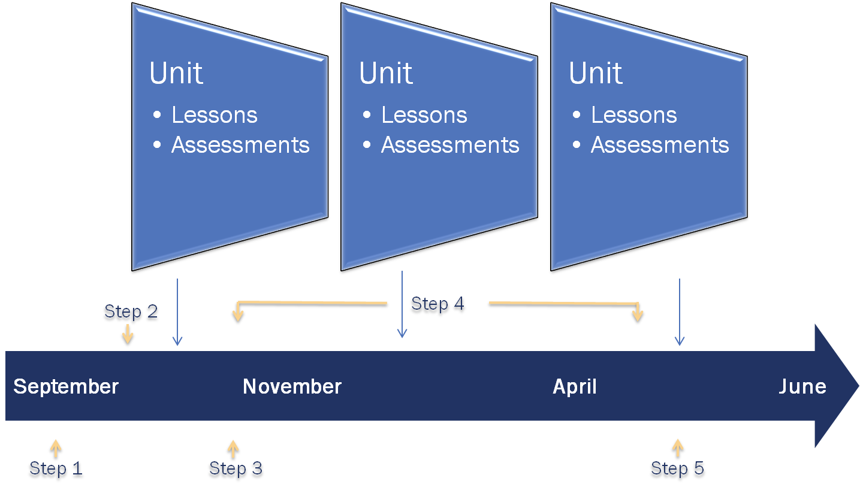
However, this framework belies the complexity of the teaching and learning cycle. Each lesson, for example, includes planning, instruction, assessment, and adjustments of strategy and material based on information collected from the students throughout the lesson. The same sort of process occurs throughout the year in different-sized cycles.
- Plan: Teachers plan for the academic year so that their students will be able to learn all the required standards. They plan what each instructional unit will look like as well as those for the week and each day. In addition, they plan what types of assessments they should give and when they should give them. The plans that teachers develop are informed by what they have learned from their work in previous years as well as what happened that day in class.
- Implement the Plan: In the teacher’s world, implementation is teaching. Teachers follow their short- and long-term plans throughout the year, adjusting as needed based on their students’ needs.
- Collect Data: To evaluate how their students are progressing, teachers assess their students continually. They collect information from question and answer sessions, during cooperative group work, through exit tickets, in analyzing homework, on unit tests and quizzes, and in many other ways. These forms of assessment all provide evidence that lets a teacher know whether her plans are resulting in the desired outcomes for her students.
- Analyze Data: Teachers analyze the data they collect from their students to find patterns that can help inform and improve their instruction and various supports they provide their students. When appropriate this analysis may lead to changes in the plan of how and what the teacher teaches, completing the cycle.

Monitoring Cycles and SGOs
Teachers should be adjusting their instruction based upon what the data from these monitoring cycles show. The key of step four of the SGO process is the adjustment of instruction that takes place as teachers monitor their students’ progress. In order to do this, these monitoring cycles must be arranged into a series of long-cycles and short-cycles. Long-cycles are longer periods of instruction covering larger sets of standards (think units of instruction), while short-cycles occur within longer ones using a wider variety of formative assessment techniques (think daily lessons). By mapping the standards taught and aligned assessments of those standards into long and short cycles, teachers can more accurately understand how students are progressing in their understanding of the material be taught.

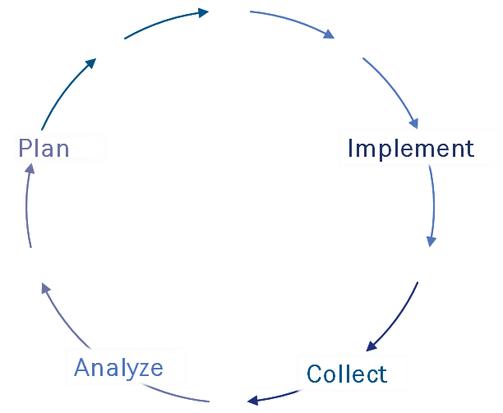
Long-Cycle Monitoring
The first of the monitoring cycles occur in long-cycles (depicted in adjacent graphic). These are longer periods of instruction covering larger sets of standards. Think of these in the similar way as you would a unit test, the time period for a project, or other longer instructional period. Multiple long-cycles will occur during an SGO period. These serve the purpose of measuring in longer chunks of time how well students are progressing towards growth on the overall set of standards being measured by an SGO. The process of long-cycles is as follows.
- During long-cycle monitoring, create a series of checkpoints to assess learning using unit or interim assessments that cover all of the standards taught during a specific longer timeframe within the SGO period.
  - Plan - Identify groups of standards students need to learn during the long-cycle. Develop an assessment to check this.
  - Implement – Put the plan into action. Teach the standards.
  - Collect – Use an assessment to identify which standards are mastered and which may need more practice.
  - Analyze – Based on analysis of this data, decide which standards may need additional practice and for which students as you move forward to the next long-cycle.
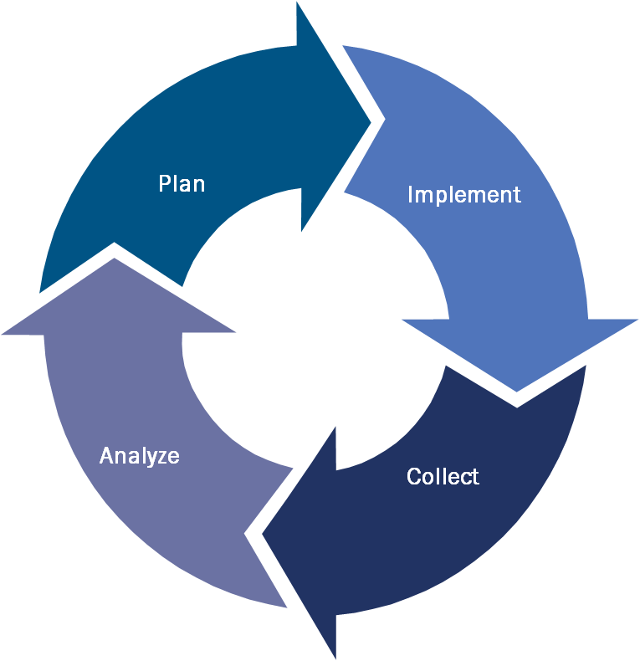
Short-Cycle Monitoring
The second of the monitoring cycles are a series of short-cycles (depicted in adjacent graphic). These are shorter periods of instruction occurring within the longer cycles. Think of these as you would any daily lesson and assessment. From using question and answer sessions and exit tickets to collaborative group work, quizzes, and homework, these short-cycles assist teachers in gauging how well their students are progressing as they move toward the long-cycle monitoring checkpoints. Multiple short-cycle assessments will occur during each long-cycle. These serve the purpose of measuring in smaller chunks of time how well students are progressing towards growth on the overall set of standards being measured during that unit of instruction. The process of short-cycle monitoring is as follows.
- Create a series of short-cycles within longer cycles using a wider variety of assessment techniques.
  - Plan – Align instruction and assessments to the standards being taught during each short-cycle.
  - Implement –Put these plans into action, using formative assessments to monitor learning along the way.
  - Collect - Collect data from these formative assessments.
  - Analyze – Based on what each short-cycle data point shows, decide which standards need more practice, and for which students. Adjusting instruction to meet these needs. Repeat as necessary moving towards the long-cycle checkpoint.

The diagram below shows the relationship between long- and short-cycle monitoring.

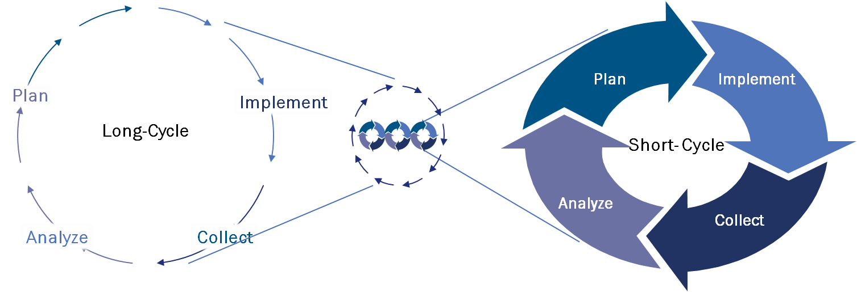

The Monitoring Cycle in Action
Below is an example of one teacher’s SGO. This example includes all five steps of the SGO process as well as monitoring cycle examples. (Note: This example refers to the social studies SGO sample found in the Appendix).

Mr. Roosevelt’s SGO
Background: Mr. Roosevelt is a high school social studies teacher at Hyde Park High. Hyde Park High has been utilizing school professional development time and resources integrating academic standards throughout the entire school curriculum to develop high quality SGOs. As a result, Mr. Roosevelt and the entire social studies team have been working hard to incorporate more writing into the social studies curriculum. This past year they received intensive training on writing in the social studies and have had numerous meeting with the English team, unpacking the standards and developing rubrics and writing protocols for their students.

SGO Steps 1-3
- Step 1: Choose or Develop a Quality Assessment:
- The social studies team has chosen an innovative approach to the assessment..
  - The research paper is a performance task, an assessment in which students create products or perform tasks to show their mastery of a particular skill.
  - The skills measured here include the important high school social studies content and literacy standards.
- The focus of the SGO integrates it into the typical cycle of teaching and learning.
  - Standards are ordered according to a logical progression in both skills and content.
- The social studies team collaboratively plans the content, skills, and assessment schedule with purpose.
  - In consultation with their supervisor and principal, using data to adjust instruction was a critical part of the SGO process for all social studies teachers this school year.

- Step 2: Determine Student Starting Points:
- Two diagnostic pre-assessments measuring student writing skills were administered. The skills measured were those students were taught during the previous year.
- Each student’s previous year’s English final course grade was used.
- Markers of future success included attendance and homework completion: both gauging student readiness for the content material.

- Step 3: Develop a Scoring Plan:
- A scoring plan was developed based on Mr. Roosevelt’s vision of success for the class.

- Step 4: Track Progress and Refine Instruction:
- Long-cycle checkpoints utilized by the team were in the form of unit tests collaboratively created or modified by Mr. Roosevelt and the rest of the social studies team.
- Short-cycle assessments were those teachers were using in class on a daily basis.

Below are examples of some of the long-cycle checkpoints and short-cycle assessments utilized in measuring the progression of this SGO.

Long-cycle Checkpoints:
The Industrial Era and the Second Long Cycle:
- 6.1.12.A.5.b (Assess the impact of governmental efforts to regulate industrial and financial systems in order to provide economic stability)
- RH.9-10.6 (Compare the point of view of two or more authors for how they treat the same or similar topics)
- RH.9-10.8 (Assess the extent to which the reasoning and evidence in a text support the author's claims)

- Plan: Building upon what was learned during the first cycle, the second one involved more complex content examples of federal government regulation (Such as laws dealing with the growth of railroads and big businesses during the Industrial Era). In addition, the common core standards addressed built upon earlier ones with more rigorous assignments. This helped Mr. Roosevelt to understand how well his students could analyze this more complex information and differing accounts supporting or refuting these policies and developments. During initial discussions the team decided on the set of standards above as the important ones for this SGO. Upon further analysis of data from the first long cycle the following two standards WHST.9-10.9 (Draw evidence from informational texts to support analysis, reflection, and research) and RH 9-10.1 (Cite specific textual evidence to support analysis of primary and secondary sources) showed students of all ability levels needed more support in.

- Implement: Short-cycle checkpoints for the upcoming unit were refined to incorporate more practice on these key standards. For instance, Mr. Roosevelt provided extra practice on these critical research and analysis skills by incorporating more analysis of readings, editorials, political cartoons, etc. (both primary and secondary sources) during this unit.

- Check: The second long-cycle assessment was the unit test on the Industrial Era. Mr. Roosevelt slightly altered the Industrial Era unit test to ensure that these standards were also being assessed at this point.

- Analyze: Upon analysis from the Industrial Era unit test, Mr. Roosevelt was confident that his students were ready for the next set of standards, as students from all three preparedness levels were progressing nicely on most of the standards. RH.9-10.8 (Assess the extent to which the reasoning and evidence in a text support the author's claims) was the only standard that some students were still struggling with.

- Plan: The cycle does not end with analysis. Based on the data from this long-cycle, additional practice on this standard would be addressed during the next long-cycle checkpoint. Mr. Roosevelt would incorporate more analysis of short primary source readings from the Progressive era. These short primary source readings were editorials of the time. Mr. Roosevelt used various groupings (both in pairs and other small groups) with various levels of teacher support to assist students in trying to master this standard.
Short-Cycle Assessments:

First Long-Cycle Checkpoint:
- Plan: The goal of the first long-cycle checkpoint was for students to develop a basic understanding of the changing role between state and federal governments. In addition, instruction and assessments centered on foundational skills related to the final SGO assessment. Short-cycle assessments were arranged to meet this goal.

- Implement: Early in the year Mr. Roosevelt presented a lesson to the class about the “Freedman’s Bureau,” an early Civil War era attempt by the Federal government to help freed slaves and poor whites in the South following the Civil War. This lesson was aimed at providing a greater understanding of NJCCCS 6.1.12.D.4.c.

- Collect: To check for understanding, Mr. Roosevelt collected an exit ticket. A short summary of the law and how it represented the ongoing battle between states’ rights versus the federal government.

- Analyze: After examining the exit tickets, Mr. Roosevelt was not happy with the responses he received and decided to re-teach the concept in a different way the next day.

- Plan: Realizing that, while the students understood the law but not the reasons for the ensuing debate on states’ rights versus federal government behind it, Mr. Roosevelt’s lesson the next day focused heavily on this concept in order to drive the point home.

Second Long-Cycle Checkpoint:
- Plan: Short-cycle assessments during this unit measured more complex content examples of federal government regulation (Such as laws dealing with the growth of railroads and big businesses during the Industrial Era). In addition, the common core standards addressed built upon earlier ones with more rigorous assignments. This helped Mr. Roosevelt to understand how well his students could analyze this more complex information and differing accounts supporting or refuting these policies and developments.

- Implement: During the Industrial Era unit students read a segment of Andrew Carnegie’s “Gospel of Wealth.” This lesson was aimed at assessing his students’ knowledge of both citing specific textual evidence to support analysis of primary and secondary sources,” (RH 9-10.1) and “Assessing the extent to which the reasoning and evidence in a text support the author's claims” (RH.9-10.8).

- Collect: They were to write a summary of the validity of the author’s points.

- Analyze: On this writing assignment it was clear that, although improvement was displayed in “citing specific textual evidence to support analysis of primary and secondary sources,” (RH 9-10.1) several students in the lower and middle tiers were not quite able to accurately “Assess the extent to which the reasoning and evidence in a text support the author's claims” (RH.9-10.8).

- Plan: Using the data, Mr. Roosevelt planned to pair struggling students up with others who were having more success and had them analyze an editorial together. Mr. Roosevelt was able to circulate and assist individually as needed.

Third Long Cycle Checkpoint:
- Plan: The era of Progressivism and the reforms of this era are traditionally some of the most difficult concepts for his students to grasp. Short cycle assessments addressed this by repeatedly checking for understanding with a greater variety and number of formative assessments.

- Implement: One formative assessment came in the form of a short quiz on the principles of the progressive movement (items such as protecting social welfare and fostering efficiency in government).

- Collect: Students took the quiz on the principles of progressivism early in the unit.

- Analyze: Data from the quiz showed that some students had difficulty understanding the connection between the principles of the movement and the actions taking place.

- Plan: Mr. Roosevelt decided that students who struggled with material during this unit would be given the opportunity to attend one of the afterschool labs Hyde Park High offered to work on material they had difficulty with in class. Once they showed competency on the concepts, they had the chance to retest on areas they had been working on. Incidentally, this has always been Mr. Roosevelt’s policy and one which many students took advantage of.

Using Assessment Data to Inform Instruction: Long and Short Cycle Monitoring
The previous examples display the ways data are used to inform instruction as teachers monitor daily lessons through short-cycle and long-cycle monitoring. These instructional units occur within the SGO period. The standards which will be assessed as part of the SGO summative assessment must be closely monitored as teachers collect data to see how their students are progressing toward mastery of the standards. Long and short cycle monitoring and its place in the SGO process is highlighted in the diagram below:

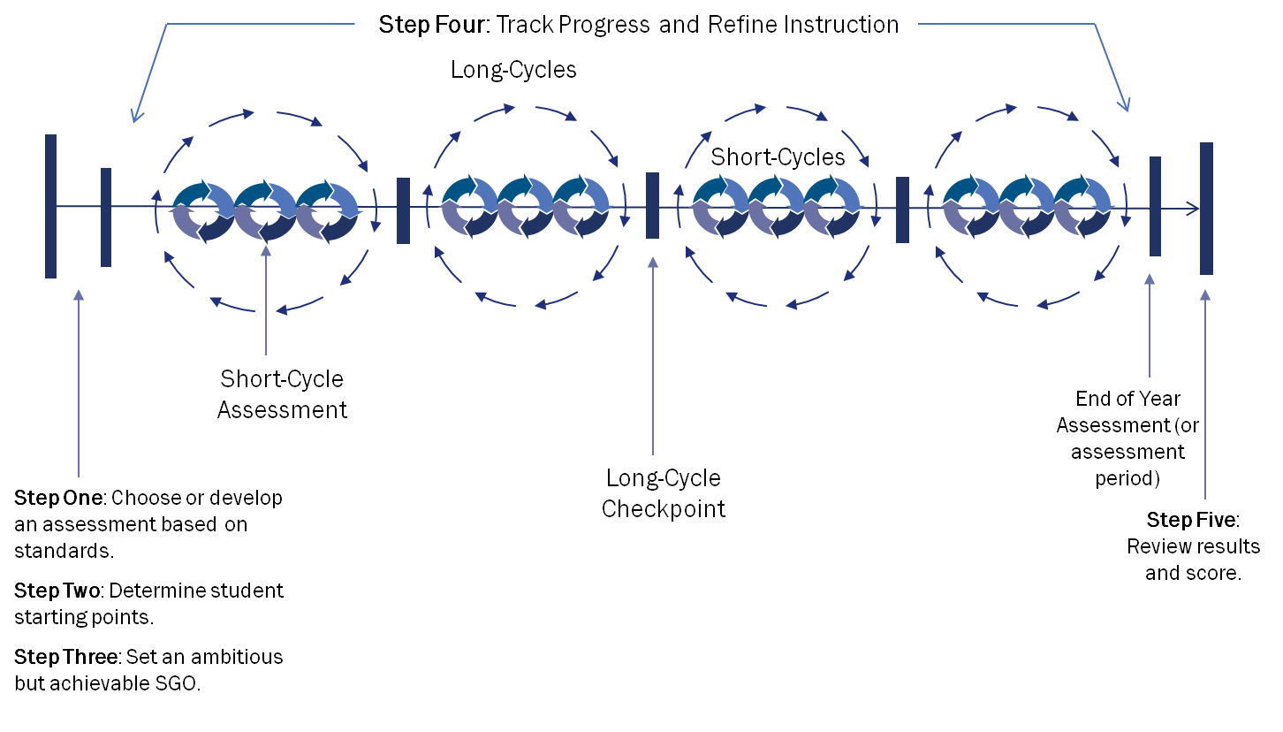
Ongoing Collaboration Between Teacher and Supervisor
One of the most critical elements of the yearly SGO cycle is the mid-year progress check. During the middle of the school year or course, you and your supervisor should check in to evaluate the progress your students are making towards the targets you have set for them. The Mid-Course Check-in Form (also found in the Appendix) may help to facilitate the discussion.

During this check-in, you can share evidence of data from both the long- and short-cycle monitoring that supports what is happening in your classroom along with adjustments to your teaching strategy. This is an excellent opportunity to demonstrate responsiveness to student needs and for your supervisor to provide guidance and support as necessary.

At this time, your data may show that it may also be appropriate to make adjustments to the scoring plan of the SGO (taking into account items such as students who have left or entered the class, or significant changes in the course or instruction that may influence the predicted outcomes of the students). Any changes that are made to the SGO must be approved by the superintendent.

Mr. Roosevelt’s Mid-Year Conference
As Mr. Roosevelt sat down with his supervisor for his mid-year conference, they reviewed selected long and short cycle data. Using this evidence, Mr. Roosevelt was able to give his supervisor a greater look into his day to day classroom. Because of this the two educators were able to have a sound discussion on student learning based on the evidence. This also gave both an even greater idea of the feasibility of the growth goals set at the beginning of the year.

Although there was evidence that Mr. Roosevelt’s goal was ambitious, they both decided the path he was taking and the responsiveness he was showing to his classroom would result in success.

SGO Step 5: As the final assessment was given and scored, Mr. Roosevelt’s students met the expectations set, and he achieved full attainment of his SGO.

Step 5: Review Results and Score

Choose/Develop Assessments
Determine Starting Points
Set Growth Objectives
Track Progress
Review and Score
1

2

3

4
5

Required
A teacher’s supervisor and/or a member of the School Improvement Panel will calculate a rating for the SGO(s).

At the end of the school year, you will compile the results of the assessment(s) used for SGOs and your supervisor will use them to formulate an SGO score.

In the example below in Figure 15, Mr. Roosevelt uses results on his SGO assessment to determine how many students met their objective. He then circles the number on his SGO scoring plan and transfers the information to the results section of the form as shown. By using a weighted method to calculate his provisional score prior to meeting with his supervisor, Mr. Roosevelt generates a score that proportionally represents the learning in his three unevenly-sized preparedness groups. This method is described in more detail in the next section.

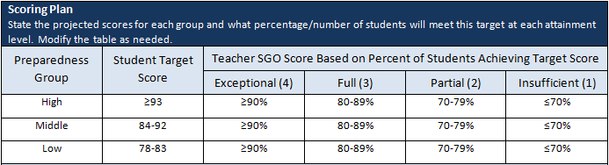
Figure 15: Determining a Weighted Score Using the Approved Scoring Plan

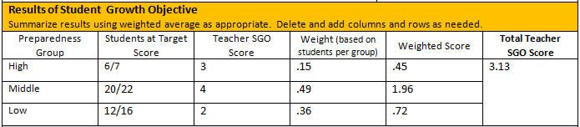

Note: The approved SGO scoring plan and assessment should be consulted when determining the final score. In rare instances where there have been significant changes in a teacher’s class that affect the teacher’s SGO score, such as truly exceptional or unusual circumstances leading to poor teacher or student attendance, the supervisor may use his or her professional judgment to provide a fair and accurate score.
Weighted Method for Calculating Tiered Student Growth Objective Scores
The simplest way to generate a score for an SGO that includes several groups of students is to assign a point value to the attainment level for each group. However, this does not take into account that the number of students in each preparedness group may significantly differ. For example, if 85% of students in the medium level group made their target, this might result in four points as “exceptional attainment” of the goal. However, perhaps only 65% of the high level group made their goal, giving a score of only “partial attainment” and two points. If both groups were of the same size, an average score of a three would fairly represent the teacher’s work. However, if there were 50 students in the medium level group and only 10 in the high level group, giving equal weight to each score would not fairly represent the overall achievement. Using a weighted score solves this problem. This can be seen in the next two tables (Figures 16 and 17).
Figure 16: Calculating Weights for Attainment Scores Based on Proportion of Students

Preparedness Group | Number of Students in Each Group | Percentage of Students in Each Group | Weight Assigned to Attainment Score*
Low | 36/65 | 56% | 0.56
Medium | 21/65 | 32% | 0.32
High | 8/65 | 12% | 0.12
*rounded to produce 1.
The calculated weights from Figure 16 can then be applied to the straight scores obtained, as shown in Figure 17.
Figure 17: Determining a Weighted Score for a Tiered SGO

Preparedness Group | Number of Students at Target Score | Objective Attainment Level | Weight | Weighted score
Low | 31 | 4 | x 0.56 | 2.24
Medium | 16 | 3 | x 0.32 | .96
High | 4 | 3 | x 0.12 | .36
 |  |  | Total | 3.56

Calculating a Total Student Growth Objective Score
A teacher with two SGOs can do a simple calculation to work out the final SGO score regardless of type of SGO, or how the score was calculated. Figure 18 demonstrates the calculation used if placing equal weight on both SGOs. A district may decide to use different weightings for each SGO.

Figure 18: Determining a Final SGO Score

Student Growth Objective | Score | Weighting |  | Weighted Score
SGO 1 | 2 | x 0.50 |  | 1.0
SGO 2 | 3 | x 0.50 |  | 1.5
 |  | Total | 2.50

Using Student Growth Objectives to Improve Practice and Student Learning
When the SGO process is carried out diligently, the resulting information will be valuable to teachers who are seeking to improve their practice. Not only can this information be used during the year to inform instruction, it can also be used to develop a well-thought out instructional plan for the following year. You might use the results from your SGOs to inform your professional development plan, choosing to focus on areas of challenge through which you or your students struggled. Further, while planning for the next school year, it may be clear from your SGO results that you should keep or expand particularly successful strategies or materials.

The SGO form contains a section where you can document your reflections on the current year’s SGO and plan for the next. See Figure 19 below.

Figure 19: Section on SGO Form for Documenting End-of-Year Reflections on SGOs

Review SGO at Annual Conference
Describe successes and challenges, lessons learned from SGO about teaching and student learning, and steps to improve SGOs for next year.

Part 4: Growth Objectives for Educational Service Professionals and Guidance for Administrators

Growth Objectives for Educational Service Professionals

SGOs are required for all teachers under AchieveNJ, but are currently only recommended by the Department for those who provide educational services such as school counselors, nurses, media specialists, CST members, and others. Many districts are requiring these educators to set SGOs and in some cases, including scores in their evaluations.

The services delivered by these specialists are diverse and differ significantly from those delivered by classroom teachers. Therefore, districts should consider approaching the SGO process differently for these educators. For all educators, no matter their role, SGOs should be specific and measurable goals that authentically measure how effectively the educator provides his or her services, whether that is helping students learn to add single digit numbers or decide which college to attend. In addition, SGOs should improve the outcomes in the educator’s area of responsibility and help him or her grow in his or her professional practice.

Within this framework, if you are an educator who typically works in schools outside of a classroom setting, first consider what type of goal you should set based on your primary responsibilities. For example, do you teach specific content to students similar to a classroom teacher, deliver educational programs or services within the school, or provide some combination of these? If a good deal of your work is directly instructing groups of students, your SGOs might look similar to those of a classroom teacher. If you provide programs or services to students, how you set and measure goals will probably look different.

For certain types of objectives, the term Student Growth Objective may not be appropriate; perhaps you are delivering a service to parents or teachers, for example. You might consider using the term Professional Growth Objective, Growth Objective, or some other term that makes sense.

Different situations with suggested approaches are shown below.
Direct Instruction to Students
You may be a nurse, media center specialist, or other certificated staff member who regularly meets with students in a more typical classroom setting and/or are responsible for direct student instruction.

Examples
- A media center specialist who teaches a marking period course of research skills sets goals for student learning and measures student success just as a typical classroom teacher would.
- A school nurse sets goals that help students learn about and manage health conditions, such as asthma.

Education Programming
If you provide educational services to students, staff, or the greater community, it might be appropriate to set growth objectives that capture this important work. This may include measuring growth in awareness of proper procedures for dealing with food allergies, the college application process, nutrition, internet safety and cyber-bullying, etc.

Examples
- A student assistance counselor presents a school-wide program to raise awareness of bullying and uses before and after surveys to determine how much students had learned from the program.
- A school counselor hosts information sessions for parents regarding various elements related to the college application process and surveys the parents’ knowledge before and after the sessions.

Examples of growth objectives for educators who provide special services can be found in the Exemplar Library. The Department is grateful for the efforts of dozens of practicing educators who collaborated to produce these examples.
Outreach Effectiveness
Specialists can also measure the reach of their services.

Example
- A learning disabilities teacher consultant develops an education program to help teachers address executive function disorder issues. She would like to increase the number of attendees to the information sessions. She develops an outreach plan and measures the increase in number of participants in the program.

SGO Implementation Advice for School and District Leaders

Administrators involved in teacher evaluation must fully understand the nature and purpose of SGOs. Only then can they effectively train teachers, monitor SGO development and quality, and provide accurate SGO ratings to teachers at the end of the year. Providing support for high-quality SGOs is not only beneficial for teachers; the evaluations of principals, assistant principals, and vice principals are closely linked to the effective implementation of SGOs and resulting success of their teachers. The following is a list of steps and resources that administrators can use to help facilitate SGO implementation.

- Step 1 - Learn about SGOs
- Review data provided by ScIP and/or DEAC on prior year's SGOs.
- Attend available NJDOE workshops on SGOs.
- Read most current SGO guidance:
- SGO Overview: 2-page overview explaining SGOs
- SGO Guidebook: In-depth "how-to" guide for setting SGOs, including forms in the Appendix
- SGO Quick Start Guide: 2-page summary of SGO Guidebook.

- Step 2 – Introduce Teachers to SGO Development for Upcoming School Year
Provide overviews of SGOs for the year in faculty meetings and other large group meetings, possibly using:
- A district-developed overview presentation reviewing SGO challenges and successes
- SGO 2.1 Presentation
- District-specific goals, timeline, and training for SGOs

- Step 3 – Provide Time and Resources for Teachers to Develop High-Quality SGOs
During time set aside for PD, PLC and team meetings, encourage teachers to use:
- Assessment Design module
- Resources in the SGO Guidebook
- SGO Exemplars: Examples of SGOs that can be used as learning tools during SGO development

- Step 4 – Evaluate SGO Quality, Approve, and Monitor Progress
Before the SGO submission deadline, review SGO quality using the following tools and guidance:
- Quality Rating Rubric: Short rubric developed to help evaluate SGOs
- Evaluating SGO Quality: Presentation developed to walk through the ideal process of reviewing SGOs
- SGO Approval Inventory and Scoring Chart: Adaptable Excel spreadsheet that can be used by evaluators as a database to track SGO development, approval, conferences and scores for teachers
During the SGO timeframe, check-in with teachers to discuss progress and provide support:
- Mid-Course Check-in Form; Optional form to promote teacher reflection and structure mid-course conversations

- Step 5 – Adjust SGOs Where Necessary and Score
Revise SGOs when necessary by February 15 using the following suggested procedures and then score once teachers have collected SGO assessment information from their students:
- Two-page explanation of the SGO assessment and adjustment process
- SGO Scoring Checkpoints and Considerations: Annotated guide with examples and resources for developing SGO scoring policies and completing the SGO process with teachers (Word | PDF)
- SGO Scoring Checklist: Simple list that administrators may use prior to or during annual conference to ensure important aspects of SGO scoring are completed (Word | PDF)
- Administering and Scoring SGO Assessments: Table including a series of optional steps districts and schools can take to increase the quality of SGO assessing and scoring (Word | PDF)

- Step 6 – Utilizing a Collaborative Approach to Improve the SGO Process.
The value of collaboration throughout the SGO process is critical in getting the greatest benefit from SGOs.
- SGO 2.1 Presentation: Strategies for infusing collaborative structures throughout the entire SGO process.
- Collaborative Team Toolkit. A set of tools designed to aid schools in maximizing the value of collaborative structures throughout the SGO process (coming soon).
.

Appendix: Forms for Setting, Assessing, and Scoring Student Growth Objectives

The forms on the following pages may be used to set, assess, and score SGOs, and evaluate the assessments that you use when setting your growth objectives. These forms can be found in Word and PDF forms on the AchieveNJ website. Their use is optional.

Student Growth Objective Form

Name |  | School |  | Grade |  | Course/Subject |  | Number of Students |  |  | Interval of Instruction
Standards, Rationale, and Assessment Method
Name the content standards covered, state the rationale for how these standards are critical for the next level of the subject, other academic disciplines, and/or life/college/career. Name and briefly describe the format of the assessment method.
Starting Points and Preparedness Groupings
State the type of information being used to determine starting points and summarize scores for each type by group. Modify the table as needed.
Preparedness Group |  | Information #1 |  |  | Information #2 |  |  |  |  | Information #3
Student Growth Objective
State simply what percentage of students in each preparedness group will meet what target in the space below, e.g. “75% of students in each group will meet the target score.” Describe how the targets reflect ambitious and achievable scores for these students. Use the table to provide more detail for each group. Modify the table as needed.
Preparedness Group  (e.g. 1,2,3) |  |  | Number of Students in Each Group |  |  |  |  |  | Target Score on SGO Assessment
Scoring Plan
State the projected scores for each group and what percentage/number of students will meet this target at each attainment level. Modify the table as needed.
Preparedness Group | Student Target Score |  | Teacher SGO Score Based on Percent of Students Achieving Target Score
 |  |  | Exceptional (4) |  |  |  | Full (3) |  | Partial (2) |  |  | Insufficient (1)
Approval of Student Growth Objective
Administrator approves scoring plan and assessment used to measure student learning.
Teacher _________________ Signature____________________  Evaluator ________________ Signature ____________________ |  |  |  |  |  |  |  | Date Submitted_______________  Date Approved _______________
Results of Student Growth Objective
Summarize results using weighted average as appropriate. Delete and add columns and rows as needed.
Preparedness Group | Students at Target Score |  | Teacher SGO Score |  |  |  | Weight (based on students per group) |  | Weighted Score |  |  |  | Total Teacher SGO Score
Notes
Describe any changes made to SGO after initial approval, e.g. because of changes in student population, other unforeseen circumstances, etc.
Review SGO at Annual Conference
Describe successes and challenges, lessons learned from SGO about teaching and student learning, and steps to improve SGOs for next year.
Teacher ____________________________ Signature ______________________ Date ___________________

Evaluator ____________________________ Signature ______________________ Date ___________________

Example SGO Form and Completion Notes
Mr. Roosevelt’s Example

Name |  | School |  | Grade |  | Course/Subject |  | Number of Students |  |  | Interval of Instruction
Franklin Roosevelt |  | Hyde Park High |  | 10 |  | US1 |  | 45 |  |  | Early September-May 15th
Standards, Rationale, and Assessment Method
Name the content standards covered, state the rationale for how these standards are critical for the next level of the subject, other academic disciplines, and/or life/college/career. Name and briefly describe the format of the assessment method.
One of the recurring themes of the US1 course is the emergence of the modern welfare state officially ushered in during the New Deal era. In this SGO students will write a research paper tracing the growth of the federal government, drawing on aspects learned throughout the year, making judgments as to its positive or negative influence on the United States of America.
In this SGO, students will display their content knowledge, as well as their ability to develop a well-designed argumentative short research paper.

This SGO will assess the following common core social studies grades 9 and 10 standards:

9-10.1: Cite specific textual evidence to support analysis of primary and secondary sources, attending to such features as the date and origin of the information.
RH.9-10.2: Determine the central ideas or information of a primary or secondary source; provide an accurate summary of how key events or ideas develop over the course of the text.
RH.9-10.3: Analyze in detail a series of events described in a text; determine whether earlier events caused later ones or simply preceded them.
RH.9-10.5: Analyze how a text uses structure to emphasize key points or advance an explanation or analysis.
RH.9-10.6: Compare the point of view of two or more authors for how they treat the same or similar topics, including which details they include and emphasize in their respective accounts.
RH.9-10.8: Assess the extent to which the reasoning and evidence in a text support the author's claims.
RH.9-10.9: Compare and contrast treatments of the same topic in several primary and secondary sources.
WHST.9-10.4: Produce clear and coherent writing in which the development, organization, and style are appropriate to task, purpose, and audience.
WHST.9-10.7: Conduct short as well as more sustained research projects to answer a question (including a self-generated question) or solve a problem; narrow or broaden the inquiry when appropriate; synthesize multiple sources on the subject, demonstrating understanding of the subject under investigation.
WHST.9-10.8: Gather relevant information from multiple authoritative print and digital sources, using advanced searches effectively; assess the usefulness of each source in answering the research question; integrate information into the text selectively to maintain the flow of ideas, avoiding plagiarism and following a standard format for citation.
WHST.9-10.9: Draw evidence from informational texts to support analysis, reflection, and research.
In addition, this SGO will assess students understanding of the changing nature of the relationship between the federal government, the states and the American people as the federal government began to take on more and more ownership of the welfare of the ordinary American citizen. This concept is addressed in the following social studies core curriculum content standards.
6.1.12.D.4.c: Analyze the debate about how to reunite the country, and determine the extent to which enacted Reconstruction policies achieved their goals.
6.1.12.D.4.e: Analyze the impact of the Civil War and the 14th Amendment on the development of the country and on the relationship between the national and state governments
6.1.12.A.5.a: Relate industrial growth to the need for social and governmental reforms.
6.1.12.A.5.b: Assess the impact of governmental efforts to regulate industrial and financial systems in order to provide economic stability.
6.1.12.A.6.a: Evaluate the effectiveness of Progressive reforms in preventing unfair business practices and political corruption and in promoting social justice.
6.1.12.A.8.a: Relate government policies to the prosperity of the country during the 1920s, and determine the impact of these policies on business and the consumer.
6.1.12.A.10.c: Evaluate the short- and long-term impact of the expanded role of government on economic policy, capitalism, and society.
6.1.12.C.10.a: Evaluate the effectiveness of economic regulations and standards established during this time period in combating the Great Depression.
6.1.12.C.10.b: Compare and contrast the economic ideologies of the two major political parties regarding the role of government during the New Deal and today.
6.1.12.D.10.b: Compare and contrast the leadership abilities of Franklin Delano Roosevelt and those of past and recent presidents.

Starting Points and Preparedness Groupings
State the type of information being used to determine starting points and summarize scores for each type by group. Modify the table as needed.
Starting points will be determined by the following items: First, a diagnostic assessment in the form of two writing samples. The writing samples were assignments given early in the school year measuring skills they were to acquire during their ninth grade ELA class. Secondly, the markers of future success used are attendance and homework completion conducted through October 15th. Finally, student’s freshmen year English grades were utilized.
Preparedness Group |  | Information #1 |  |  | Information #2 |  |  |  |  | Information #3
 |  | Diagnostic Assessment in the form of their writing samples. |  |  | Markers of Future Success |  |  |  |  | Freshmen year’s English grade
High |  | ≥90% and above |  |  | 6 points |  |  |  |  | ≥90%
Middle |  | 78-89% |  |  | 4-5 points |  |  |  |  | 78-89%
Low |  | ≤77% |  |  | 1-3 points |  |  |  |  | ≤77%
Student Growth Objective
State simply what percentage of students in each preparedness group will meet what target in the space below, e.g. “75% of students in each group will meet the target score.” Describe how the targets reflect ambitious and achievable scores for these students. Use the table to provide more detail for each group. Modify the table as needed.
Preparedness Group  (e.g. 1,2,3) |  |  | Number of Students in Each Group |  |  |  |  |  | Target Score on SGO Assessment
High |  |  | 7 |  |  |  |  |  | ≥93
Middle |  |  | 22 |  |  |  |  |  | 84-92
Low |  |  | 16 |  |  |  |  |  | 78-83
Scoring Plan
State the projected scores for each group and what percentage/number of students will meet this target at each attainment level. Modify the table as needed.
Preparedness Group | Student Target Score |  | Teacher SGO Score Based on Percent of Students Achieving Target Score
 |  |  | Exceptional (4) |  |  |  | Full (3) |  | Partial (2) |  |  | Insufficient (1)
High | ≥93 |  | ≥90% |  |  |  | 80-89% |  | 70-79% |  |  | ≤70%
Middle | 84-92 |  | ≥90% |  |  |  | 80-89% |  | 70-79% |  |  | ≤70%
Low | 78-83 |  | ≥90% |  |  |  | 80-89% |  | 70-79% |  |  | ≤70%
Approval of Student Growth Objective
Administrator approves scoring plan and assessment used to measure student learning.
Teacher _________________ Signature____________________  Evaluator ________________ Signature ____________________ |  |  |  |  |  |  |  | Date Submitted_______________  Date Approved _______________
Results of Student Growth Objective
Summarize results using weighted average as appropriate. Delete and add columns and rows as needed.
Preparedness Group | Students at Target Score |  | Teacher SGO Score |  |  |  | Weight (based on students per group) |  | Weighted Score |  |  |  | Total Teacher SGO Score
High | 6 |  | 3 |  |  |  | .15 |  | .45 |  |  |  | 3.13
Middle | 20 |  | 4 |  |  |  | .49 |  | 1.96
Low | 12 |  | 2 |  |  |  | .36 |  | .72
Notes
Describe any changes made to SGO after initial approval, e.g. because of changes in student population, other unforeseen circumstances, etc.
Although no changes were made by the February 15th deadline, by tracking progress and refining instruction throughout, I was able to target some items that students particularly in the low preparedness group, were struggling with and adapt their instruction and assessing on these skills raising his classes’ overall achievement.
Review SGO at Annual Conference
Describe successes and challenges, lessons learned from SGO about teaching and student learning, and steps to improve SGOs for next year.
The greatest success from this year’s SGO occurred while I was tracking progress. During the unit on Progressivism, assessment data showed many of my students having trouble grasping the concepts of laws and their relationship to the benefit of the social welfare of the people. In addition, from the first writing sample throughout much of the year this group struggled with the causational relationship of some laws and events to others (CCSS.ELA-LITERACY.RH.9-10.3). Because of the data revealing this, I was able to adjust my instruction and content analysis accordingly.
Teacher ____________________________ Signature ______________________ Date ___________________

Evaluator ____________________________ Signature ______________________ Date _________________

Student Growth Objective Quality Rating Rubric
This rubric is a teaching tool that may be used by teachers and administrators to work towards producing high-quality SGOs. This rubric describes activities and components of SGOs that align with guidance documents and presentations previously published by the Department. The State requirements for SGOs can be found in regulations at NJAC 6A:10-4.2(e). Any score generated using this rubric cannot be used as part of a teacher’s required evaluation rating.
Excellent |  | Good |  | Fair |  | Inadequate |  | Resources
RATIONALE FOR SGO/STANDARDS CHOSEN
Includes all or most standards for which the teacher is responsible during the instructional period. |  | Includes at least half of the standards for which the teacher is responsible during the instructional period. |  | Includes some of the standards for which the teacher is responsible during the instructional period. |  | Includes few of the standards for which the teacher is responsible during the instructional period. |  | SGO Guidebook  Effective Assessments Module  Assessment Design Modules  SGO Exemplars
Articulates how the majority of selected standards are critical to enduring understanding of the subject area, success in future classes, and readiness in college, career, and life. |  | Articulates how some selected standards are critical to enduring understanding of the subject area, success in future classes, and readiness in college, career, and life. |  | Articulates how some selected standards lead to future success. |  | Does not justify how the standards chosen lead to future success or does so poorly. |  | SGO Guidebook  SGO 2.1 Presentation  Assessment Design Modules  SGO Exemplars
ASSESSMENTS
Aligns all items to the chosen standards taught during the SGO period. All critical standards have multiple items. |  | Aligns most items to the chosen standards taught during the SGO period. Most critical standards have multiple items. |  | Aligns some items to the chosen standards taught during the SGO period. Some critical standards have multiple items. |  | Aligns few or no items to the chosen standards. Critical standards are not identified and have few items. |  | SGO Guidebook  SGO 2.1 Presentation
Range of rigor accurately reflects rigor of instruction, content, and skills of course. |  | Range of rigor mostly reflects rigor of instruction, content, and skills of course. |  | Range of rigor somewhat reflects rigor of instruction, content, and skills of course. |  | Range of rigor does not reflect rigor of instruction, content, and skills of course. |  | SGO Guidebook  SGO 2.1 Presentation  Assessment Design Modules
Highly accessible to all students regardless of background knowledge, cultural differences, or special needs. |  | Mostly accessible to all students regardless of background knowledge, cultural differences, or special needs. |  | Somewhat accessible to all students regardless of background knowledge, cultural differences, or special needs. |  | Disadvantages certain students because of background knowledge, cultural differences, or special needs. |  | SGO Guidebook  SGO 2.1 Presentation  Assessment Design Modules
Assessment design is consistently high quality. Includes rubrics, scoring guides, and/or answer keys for all items, all of which are accurate, clear, and thorough. |  | Assessment design is mostly high quality. Includes rubrics, scoring guides, and/or answer keys for all items, most of which are accurate, clear, and thorough. |  | Assessment design is of moderate quality. Includes rubrics, scoring guides, and/or answer keys for some items, most of which are accurate, clear, and thorough. |  | Assessment design is of low quality in virtually all aspects of design. |  | SGO Exemplars  Effective Assessment Module  Assessment Design Modules
Teachers of the same subject matter /grade level use a common summative assessment |  | Teachers of the same subject matter/grade level’s summative assessments are similar but not the same. |  | Teachers of the same subject matter/grade level’s summative assessments of the same standards are different. |  | Teachers of the same subject matter/grade level assess different standards in different ways. |  | Effective Assessment Module  Collaborative Teams Toolkit  SGO 2.1 Presentation  SGO Guidebook
Excellent | Good |  | Fair |  | Inadequate |  | Resources
COLLABORATION
Most, or all, key decisions were made collaboratively between teachers (and/or teachers and administrators). | Many key decisions were made collaboratively between teachers (and/or teachers and administrators). |  | Some key decisions were made collaboratively between teachers (and/or teachers and administrators. |  | Few or no key decisions are made collaboratively by teachers (and/or teachers and administrators). |  | SGO Guidebook  SGO 2.1 Presentation  Collaborative Teams Toolkit  SGO Integration Tool  Mid Course Check In
TRACKING PROGRESS AND REFINING INSTRUCTION
Standards are assessed in a way that growth is logically measured and is regularly monitored with instruction adjusted accordingly throughout the school year. | Standards are assessed in a way that growth is logically measured and is regularly monitored throughout the school year. |  | Standards are assessed in a way that growth is logically measured logically throughout the school year. |  | Standards are assessed in a way that growth cannot be measured or monitored until the summative assessment is given. |  | SGO Guidebook  SGO 2.1 Presentation  Collaborative Teams Toolkit  SGO Integration Tool  Effective Assessments Module  Data-Driven Decisions Module  Assessing and Adjusting SGOs
Common assessments are used as checkpoints in measuring growth. | Common assessments are used in measuring growth. |  | Common assessments are rarely used in measuring growth. |  | Commons assessments are not in use in measuring growth. |  | Collaborative Teams Toolkit  Effective Assessments Module  Data-Driven Decisions Module
STARTING POINTS/SCORING PLAN
Multiple, high quality measures of baseline data are used to determine student starting points. | Multiple measures of baseline data, the quality of which may vary, are used to determine student starting points. |  | A single measure of high quality is used to determine student starting points. |  | A single measure of low quality is used to determine student starting points. |  | SGO Guidebook  SGO Exemplars  SGO Excel Scoring and Tracking Workbook
Student learning targets are differentiated to be ambitious and achievable for all or nearly all students. | Student learning targets are differentiated to be ambitious and achievable for a majority of students. |  | Student learning targets are differentiated to be ambitious and achievable for some students. |  | Student learning targets are not differentiated or are set too low. |  | SGO Guidebook  SGO Exemplars  SGO Excel Scoring and Tracking Workbook
“Full attainment” accurately reflects a teacher’s considerable impact on student learning. . “Exceptional attainment” clearly exceeds the objective set. | “Full attainment” somewhat reflects a teacher’s impact on student learning. “Exceptional attainment” of the SGO does little to reflect the teacher’s impact on student learning. |  | “Full attainment” loosely reflects a teacher’s impact on student learning. “Exceptional” was easily attained by a less than ambitious scoring plan. |  | “Full attainment” is too low or too high to accurately represent a teacher’s considerable impact on student learning. |  | SGO Guidebook  SGO Exemplars  SGO Excel Scoring and Tracking Workbook  Assessing and Adjusting SGOs
Scoring range is justified by analysis of baseline data and the rigor of the assessment | Scoring range is implied by presented baseline data and the rigor of the assessment. |  | Scoring range is somewhat reflected by baseline data and the rigor of the assessment. |  | Scoring range is not reflected by baseline data and the rigor of the assessment. |  | SGO Guidebook  SGO Exemplars  SGO Excel Scoring and Tracking Workbook

Depth of Knowledge/Rigor Chart and Checklist
Use the following chart to help create and categorize assessment items. The range of rigor of the assessment items should reflect the rigor of the course content and instruction. Use in conjunction with the Depth of Knowledge wheel and transfer this information to your assessment blueprint.

Level | Learner Action | Key Actions | Sample Question Stems | Question Numbers/Portfolio Components
Level 1:  Recall | Requires simple recall of such information as a fact, definition, term, or simple procedure. | List, Tell, Define, Label, Identify, Name, State, Write, Locate, Find, Match, Measure, Repeat | How many...?  Label parts of the….  Which is true or false...?
Level 2:  Concept | Involves some mental skills, concepts, or processing beyond a habitual response; students must make some decisions about how to approach a problem or activity. | Estimate, Compare, Organize, Interpret, Modify, Predict, Cause/Effect, Summarize, Graph, Classify | Identify patterns in...  Use context clues to... Predict what will happen when...  What differences exist between...?  If x occurs, y will….
Level 3:  Strategic Thinking | Requires reasoning, planning, using evidence, and thinking at a higher level. | Critique, Formulate, Hypothesize, Construct, Revise, Investigate, Differentiate, Compare | Construct a defense of…. Can you illustrate the concept of…?  Apply the method used to determine...?  Use evidence to support….
Level 4:  Extended Thinking | Requires complex reasoning, planning, developing, and thinking, most likely over an extended time. Cognitive demands are high, and students are required to make connections both within and among subject domains. | Design, Connect, Synthesize, Apply, Critique, Analyze, Create, Prove, Support | Design x in order to…..  Develop a proposal to…. Create a model that….  Critique the notion that…

Mid-Course Check-in

Teacher: __________________________________________ Date: ___________________

Grade Level/
Subject/Period: ____________________________________

Evaluator: _________________________________________

In preparation for the mid-course progress check-in, please complete this questionnaire and submit it to your evaluator. You may attach your responses to this form or write them here directly.

- How are your students progressing toward your student growth objectives? How do you know?

- Which students are struggling/exceeding expectations? What are you doing to support them?

- What additional resources do you need to support you as you work to achieve your student growth objectives?

- Are there any student attendance issues substantial enough to affect your student growth objectives?

Please return this form to your primary evaluator, along with your SGO forms, and any interim student learning data you would like to discuss during the check-in.

The Department recommends that teachers of 4th-8th-grade Language Arts and 4th-7th-grade Math set 2 SGOs if they have 25 students or fewer (30 or fewer in districts where student mobility is high). This ensures that a teacher will have at least two measures of student achievement if no mSGP is available. Please see the SGP web page for more information.
https://www.stephencovey.com/7habits/7habits-habit2.php
http://www.ascd.org/publications/books/103055.aspx
The Assessment Design blueprint which accompanies the modules differs in a few ways from the Department’s original blueprint. To avoid confusion, the blueprint in this section and guidebook is the one aligned to the modules. If your district has been utilizing the Department’s original blueprint, it can still be utilized with slight modifications when viewing the modules and can still be accessed here. In addition, a document describing the differences can be accessed here.
Moody, Michael, and Jason Stricker, Strategic Design for Student Achievement (2008).
New Jersey Core Curriculum Content Standards, including the Common Core State Standards, and other standards approved by the State Board of Education
For teachers in tested subjects and grades, their mSGP rating includes a significant number of standards and students. Therefore, their SGOs may address a more targeted student group, content area or set of skills. SGOs may be designed to reinforce standards measured on PARCC or address subjects not included in the state test.
Items: Performance-based or portfolio tasks, or questions on an assessment that measure learning.
Critical standards: Those that lead to enduring understanding and/or future success in school/college/career/life.
In cases of teachers who teach the only course of a particular type that is offered, this component can be used to assess general collaboration within a department or team.
Key Decisions: Those that surround assessment development, baseline measures, data-driven instruction, scoring plan parameters, etc. Key decisions should follow the guidance offered in the SGO Integration Tool.
See footnote 4.

