NJ Department of Community Affairs
RFP for Consulting Services for the
FFY 2023 Annual Action

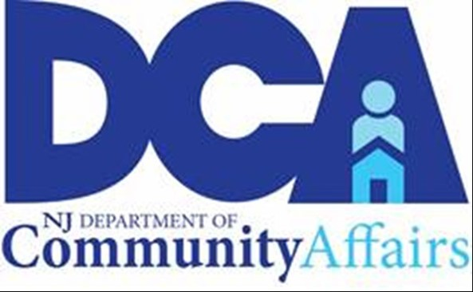

State of New Jersey
Phil Murphy, Governor
Department of Community Affairs
Lt Governor Sheila Y. Oliver, Commissioner

REQUEST FOR PROPOSALS

Contents
BACKGROUND INFORMATION: 2
BUDGET: 2
SCOPE OF WORK: 2
PROPOSAL SECTIONS: 3
AWARD CRITERIA: 3
PROPOSAL SUBMISSION REQUIREMENTS: 3
PROPOSAL SUBMISSION DEADLINE: 3
GENERAL INFORMATION AND REQUIREMENTS: 4

BACKGROUND INFORMATION:
The NJ Department of Community Affairs (DCA) seeks a qualified professional consultant to draft the Consolidated Plan FFY 2023 Action Plan.

Consolidated Plan: FFY 2023 Action Plan
New Jersey's HUD-CPD Programs include the Community Development Block Grant Program (CDBG), Emergency Solutions Grant Program, HOME Investment Partnership Program, Housing Opportunities for Person with AIDs (HOPWA), and the Housing Trust Fund Program (HTF).

Consultants must follow the requirements at:
- Consolidated Plan requirements at HUD CPD Notice-12-009
- The Consolidated Plan IDIS Desk Guide found at https://www.hudexchange.info/consolidated-plan/econ-planning-suite
- The Consolidated Plan Guides, Tools and Training found at: https://www.hudexchange.info/programs/consolidated-plan/guides/#consolidated-plan-template-in-idis
- The Consolidated Plan Regulations and Federal Notices found at:
https://www.hudexchange.info/programs/consolidated-plan/consolidated-plan-regulations-and-federal-register-notices/

The consultant must be willing to commit to a timeline that includes the following phases over a 3-month period:
- Data collection and analysis
- Stakeholder consultation and public meetings
- Draft Annual Action Plan
- Conduct a public hearing on draft plan
- Draft response to comments received
- Enter final plans into IDIS

BUDGET:
DCA estimates a budget of up to $20,000 for the completion of this work. Proposed budgets must include expected itemized costs for each scope of work as described below.

SCOPE OF WORK:
- Data collection and analysis
- Stakeholder consultation
- Draft of Annual Action Plan including:
AP-15 Expected Resources
AP-20 Annual Goals and Objectives
AP-25 Allocation Priorities
AP-30 Method of Distribution
AP-35 Projects
AP-40 Section 108 Loan Guarantee
AP-45 Community Revitalization Strategies
AP-50 Geographic Distribution
AP-55 Affordable Housing
AP-60 Public Housing
AP-65 Homeless and Other Special Needs Activities
AP-70 HOPWA goals
AP-75 Barriers to affordable housing
AP-85 Other Actions
AP-90 Program Specific Requirements
- Public hearing on draft
- Draft response to comments
- Enter final plan into IDIS

PROPOSAL SECTIONS:
The proposal shall include, at a minimum, the following mandatory sections:
- Cover Letter
- Qualifications: Provide the name, address, telephone number and email address of the primary contact person. Identify all individuals anticipated to be involved in this project and the role each is expected to fill. Provide resumes for everyone identified
- Experience: Describe successful projects of similar size and scope (previous state-level Consolidated Plan experience is preferred); working knowledge of the Consolidated Plan and the HUD Community Development and Planning Programs, including the regulations and requirements
- Proposed plan for developing an Annual Action Plan
- Schedule of proposed activities with timeline and proposed completion date(s).
- Price proposal and estimated time to complete project
- References

AWARD CRITERIA:
- Understanding of work to be performed
- Professional expertise of team
- Prior experience relative to project
- Quality of scope of services and project schedule
- Fee schedule and cost

PROPOSAL SUBMISSION REQUIREMENTS:
Email one complete scanned version to Sheri Malnak at sheri.malnak@dca.nj.gov

PROPOSAL SUBMISSION DEADLINE:
- 4 PM on February 28, 2023
- Late or incomplete submittals will be rejected

RFP TIMELINE:

RFP Released: February 6, 2023

RFP Deadline for Submission: February 28, 2023

Award announced: March 17, 2023

Deadline for all items to be completed: June 30, 2023

GENERAL INFORMATION AND REQUIREMENTS:
- All work will be performed on a fixed-rate, cost-incurred basis. Final payment is subject to a satisfactory final product, as determined by DCA.
- All deliverables must be submitted in draft form and will not be considered as final until accepted by DCA. Vendor shall be provided with an opportunity to remedy deficiencies, if necessary, for DCA approval but work must be completed within initial budget.
- If DCA determines progress, as measured by the agreed upon timeline and activity description, is inadequate, it reserves the right to terminate the contract with a 30-day written notice.
- Although cost is a factor, DCA reserves the right to select the consultant that best suits its needs.
- Any changes in project cost, timeline, or scope during the contract must be pre-approved in writing by both the parties.

